Operating System (CSL303) Lab Workbook

Session: 2025-26

**Operating System CSL303**

**Lab Workbook**



**Faculty name: Dr. Asha Sohal Student name:Kunal sharmaRoll No.: 23csu396**

**Semester: 5th**

**Group: 2 (Data Science A)**

Department of Computer Science and Engineering

The NorthCap University

Gurugram- 122017, India

Session 2025-26

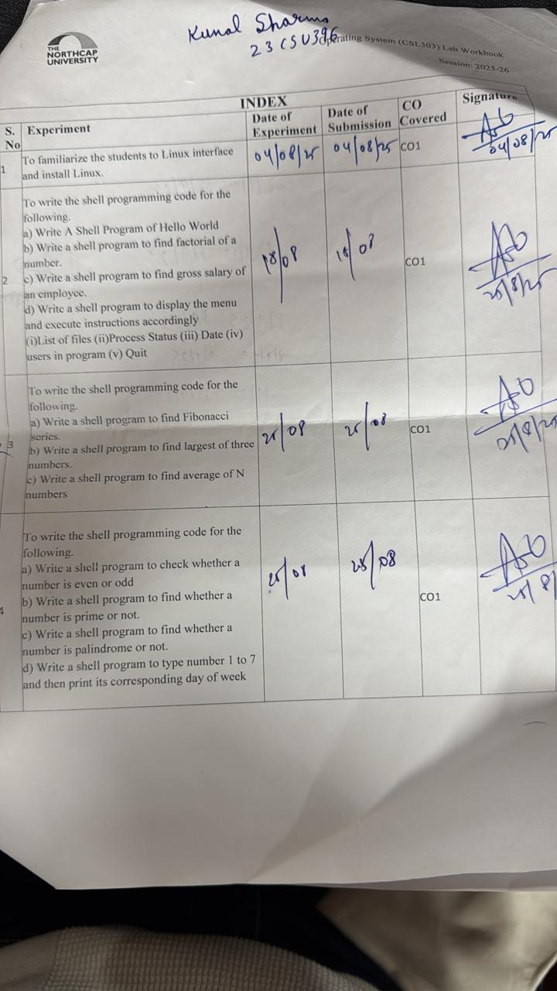

# INDEX

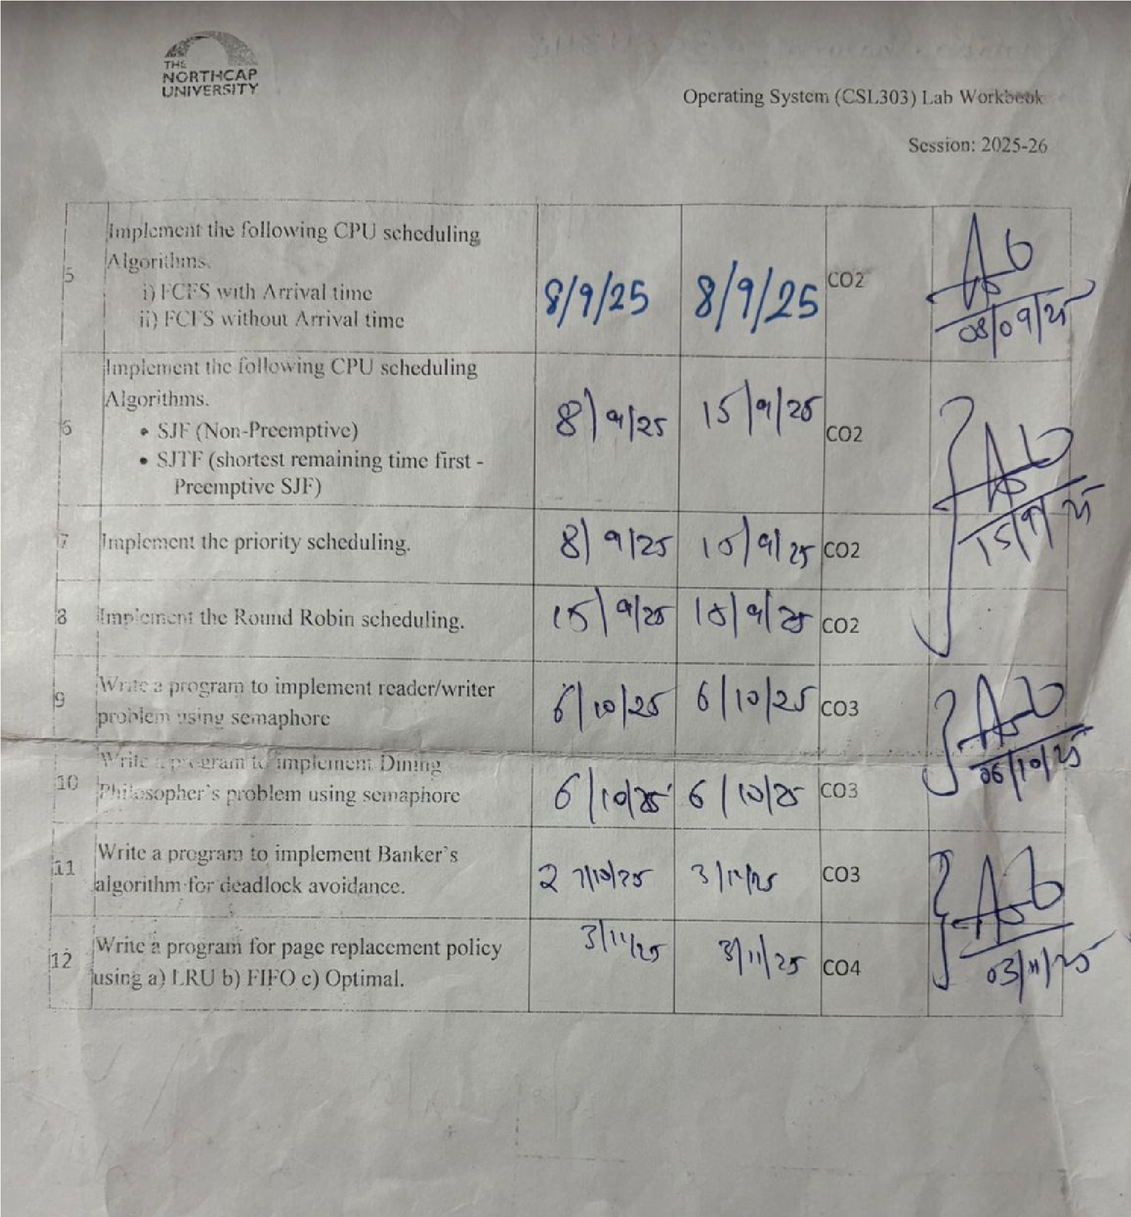

# Experiment No: 1

|  |
| --- |
| **Student Name and Roll Number: Kunal sharma 23csu396** |
| **Semester /Section**: 5th / Data Science A |
| **Link to Code:** |
| **Date: 04 / 08 / 25** |
| **Faculty Signature: Dr. Asha Sohal** |
| **Marks:** |

|  |
| --- |
| **Objective(s):**  To familiarize the students to Linux interface. |
| **Outcome:**  • The students will understand commands used in Linux. |
| **Problem Statement:**  Implement the following things:  • Linux Installation |
| **Background Study:**  Cygwin is a open source tool which provides that functionality of the Linux in windows Operating System. Cygwin is a large collection of GNU and Open Source tools which provide functionality similar to a [Linux distribution](https://en.wikipedia.org/wiki/Linux_distribution) on Windows. It is a DLL (cygwin1.dll) which provides substantial POSIX API functionality. |
| **Question Bank:**   1. **What is Linux?**   **Ans** Linux is a free, open-source operating system used to run servers, desktops, mobile devices, and more. It’s based on Unix and supports multitasking and multiuser functionality.   1. How will you List files from a directory? |

Ans **ls**

1. How files in a directory can be removed?

Ans **rm filename**

1. How to find out a word in a file?

Ans **grep "word" filename**

1. What are wildcards?

Ans **Wildcards are symbols used to match filenames or patterns.**

# Student Work Area

## Algorithm/Flowchart/Code/Sample Outputs

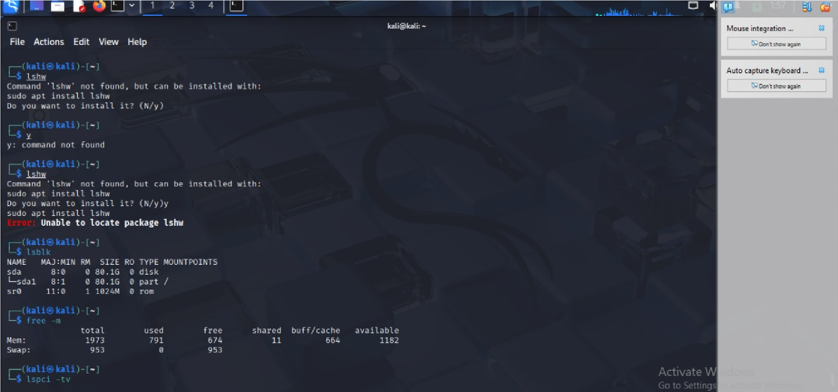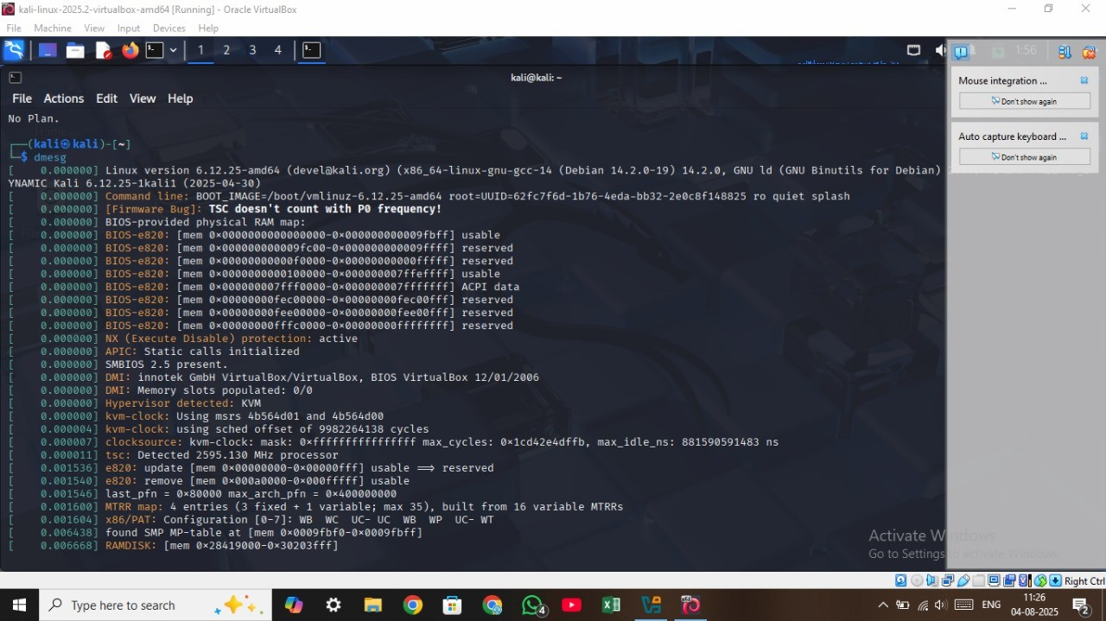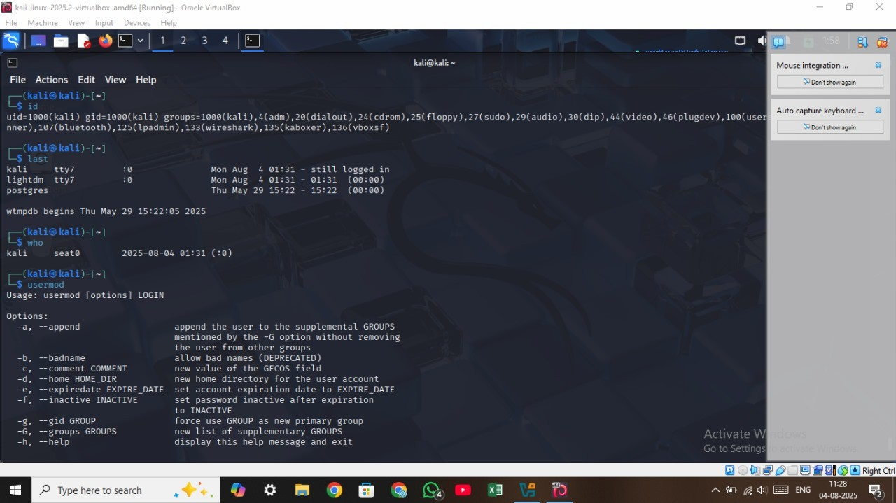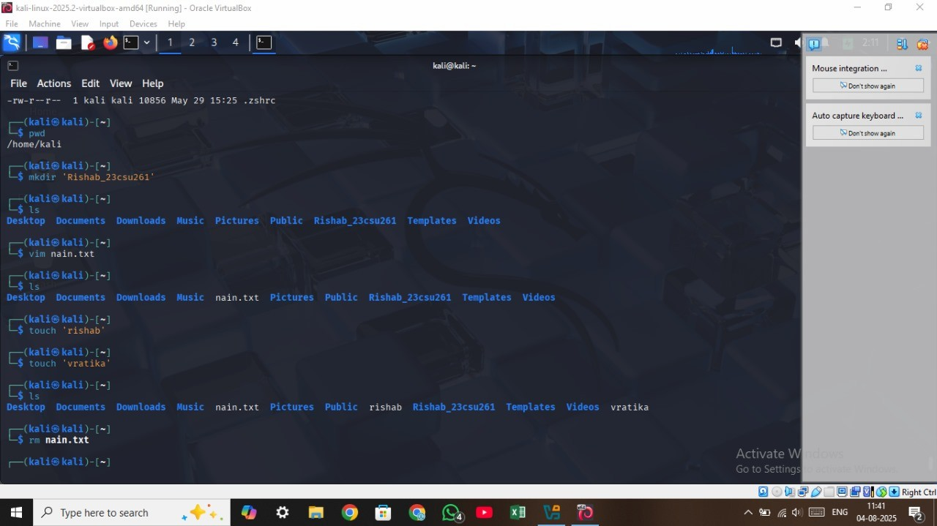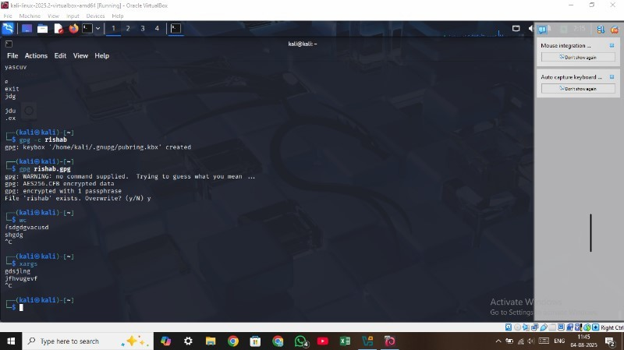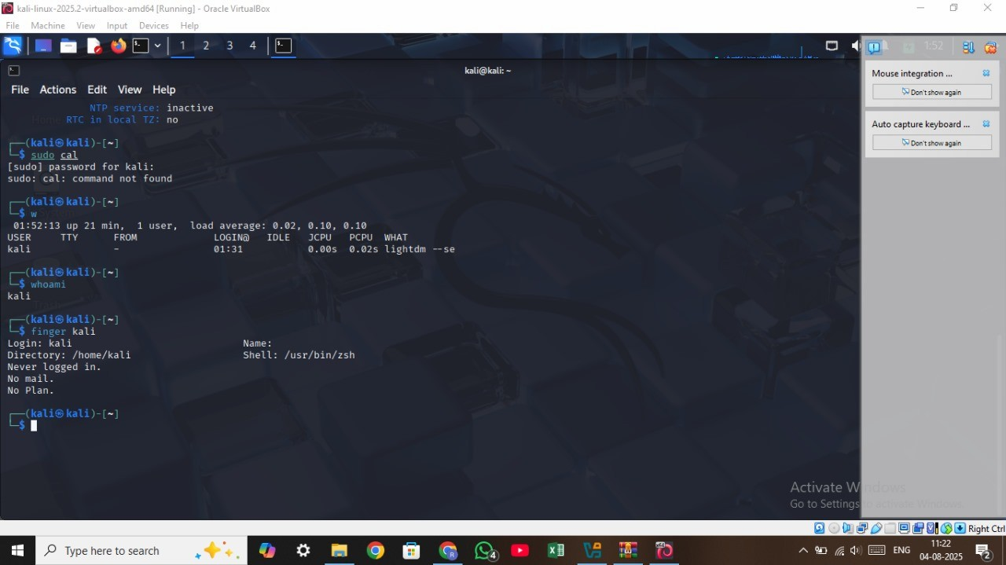

## Experiment No: 2

|  |
| --- |
| **Student Name and Roll Number: Kunal sharma 23csu396** |
| **Semester /Section: 5th / Data Science A** |
| **Link to Code:** |
| **Date: 18/08/25** |
| **Faculty Signature: Dr. Asha Sohal** |
| **Marks:** |

|  |
| --- |
| **Objective(s):**  To write the shell programming code for the following. |
| **Outcome:**  • Student is able to write code in shell programming. |
| **Problem Statement:**   1. Write A Shell Program of Hello World 2. Write a shell program to find factorial of a number. 3. Write a shell program to find gross salary of an employee. 4. Write a shell program to display the menu and execute instructions accordingly   • (i)List of files (ii)Process Status (iii) Date (iv) users in program (v) Quit |
| **Background Study:**  A shell script is a file with a set of commands in it. The shell reads this file and executes the instructions as if they were input directly on the command line.  A shell is a command-line interpreter and operations such as file manipulation, program execution and text printing are performed by shell script. So, we will use vi editor to edit our files. |
| **Question Bank:**  **1. What is a shell?** |

**Ans A shell is a command-line interface that lets users interact with the OS and run commands or scripts.**

1. **What is the significance of $#?**

**Ans $# gives the number of arguments passed to a script.**

1. **What are the different types of commonly used shells on a typical Linux system?**

**Ans Commonly used shells in Linux : bash, sh, zsh, csh, ksh, and dash.**

1. **How will you pass and access arguments to a script in Linux?**

**Ans Arguments are passed after the script name and accessed using $1, $2, ..., $#, $@.**

1. **Use sed command to replace the content of the file (emulate tac command) Ans sed '1!G;h;$!d' filename.txt reverses file line order like tac**

# Student Work Area

## Algorithm/Flowchart/Code/Sample Outputs

1. Write A Shell Program of Hello World #!/bin/bash echo "Hello World"

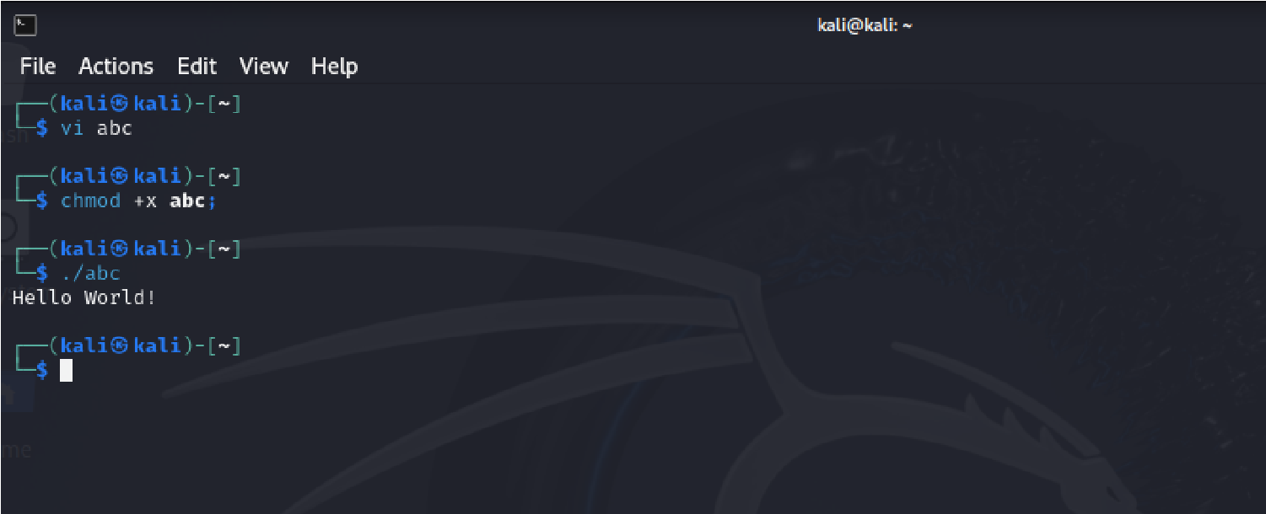

1. Write a shell program to find factorial of a number.

#!/bin/bash

echo -n "Enter a number: " read num fact=1 for ((i=1; i<=num; i++)) do

fact=$((fact * i))

done echo "Factorial of $num is $fact"

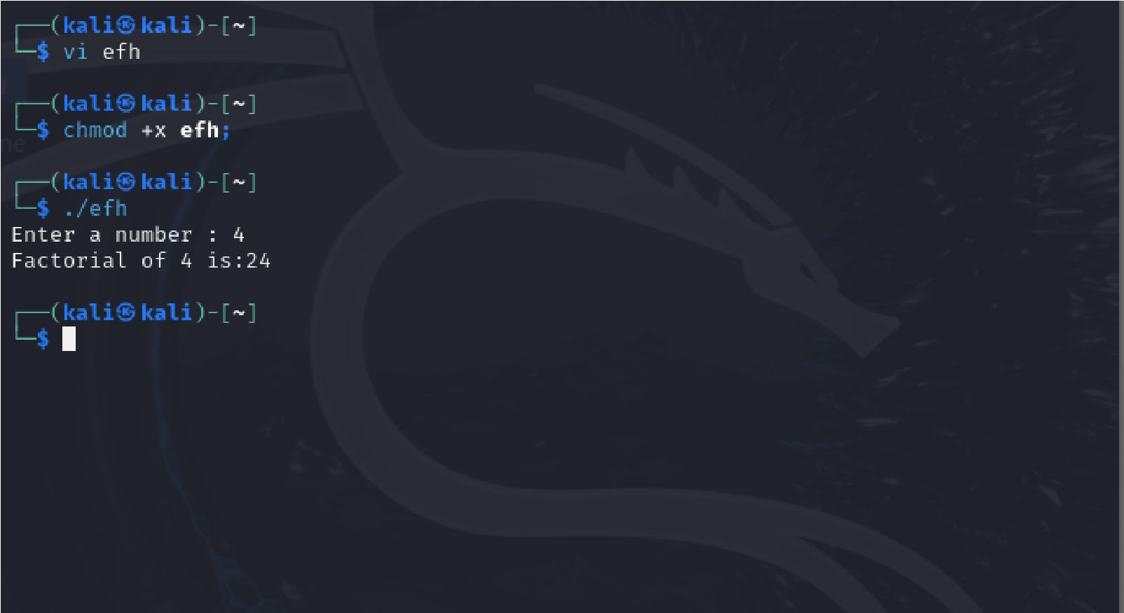

1. Write a shell program to find gross salary of an employee. #!/bin/bash echo -n "Enter Basic Salary: " read basic

da=$(( (basic * 40) / 100 )) # 40% DA

hra=$(( (basic * 20) / 100 )) # 20% HRA

gross=$((basic + da + hra))

echo "Basic Salary : Rs.$basic" echo "DA (40%) : Rs.$da" echo "HRA (20%) : Rs.$hra" echo "Gross Salary : Rs.$gross"

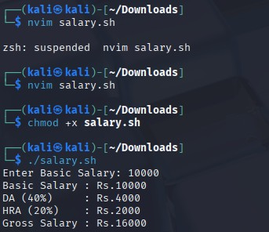

1. Write a shell program to display the menu and execute instructions accordingly

(i)List of files (ii)Process Status (iii) Date (iv) users in program (v) Quit

#!/bin/bash while true do echo " MENU "

echo "1. List of files"

echo "2. Process Status" echo "3. Date" echo "4. Users in system" echo "5. Quit" echo -n "Enter your choice: " read ch case $ch in

1. ls ;;
2. ps ;;
3. date ;;
4. who ;;
5. echo "Exiting..."; exit ;; *) echo "Invalid choice" ;; esac

done

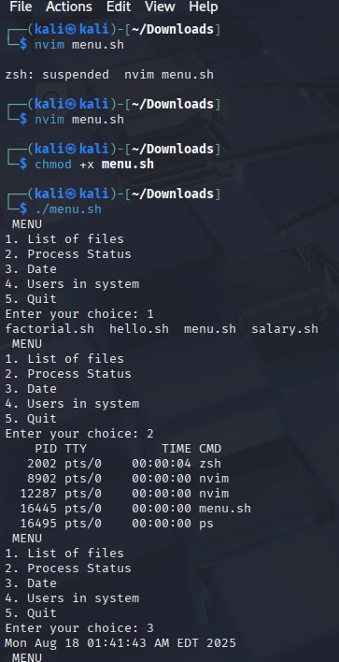

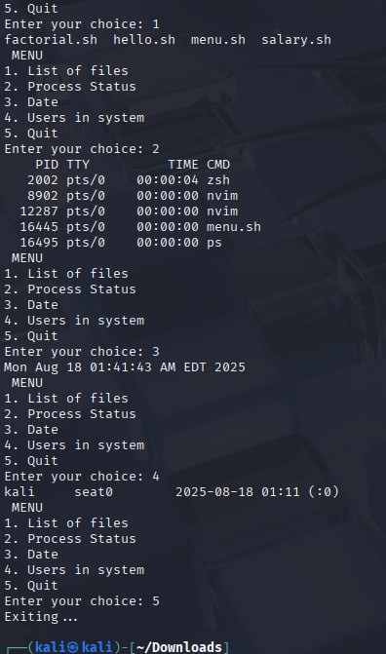

## EXPERIMENT NO. 3

|  |
| --- |
| **Student Name and Roll Number: Kunal sharma 23csu396** |
| **Semester /Section: 5th / Data Science A** |
| **Link to Code:** |
| **Date: 25/08/25** |
| **Faculty Signature: Dr. Asha Sohal** |
| **Marks:** |
| **Objective:**  To write the shell programming code for the following. | |
| **Outcome:**  Student is able to write code in shell programming | |
| **Problem Statement:**   1. Write a shell program to find Fibonacci series. 2. Write a shell program to find largest of three numbers. 3. Write a shell program to find average of N numbers | |
| **Background Study:**  A shell script is a file with a set of commands in it. The shell reads this file and executes the instructions as if they were input directly on the command line.  A shell is a command-line interpreter and operations such as file manipulation, program execution and text printing are performed by shell script. So, we will use vi editor to edit our files. | |
| **Question Bank:** | |
| 1. **How to use multi line comments in shell script? Ans Using : <<'EOF' or Use # on each line** 2. **What is the difference between soft and hard links?**   **Ans A hard link points directly to the file's data (same inode), so it still works if the original file is deleted. A soft link (symbolic link) points to the file's path, and it breaks if the original file is removed. Hard links can't span filesystems or link to directories, while soft links can.**   1. **Explain about loops and what are the loops available in LINUX?**   **Ans Loops in Linux shell scripting repeat commands multiple times. The main types are:**  **for — loops through a list of items while — runs while a condition is true until — runs until a condition becomes true select — creates a menu for user input They help automate repetitive tasks easily.**   1. **What are absolute and relative paths.**   **Ans Absolute paths start from the root / and show the full location (e.g.,**  **/home/user/file.txt). Relative paths are based on the current directory (e.g., ./file.txt or**  **../file.txt).**   1. **How to debug a shell script.**   **Ans Run with bash -x, add set -x in the script, and use echo to print variables for debugging.** | |

# Student Work Area

## Algorithm/Flowchart/Code/Sample Outputs

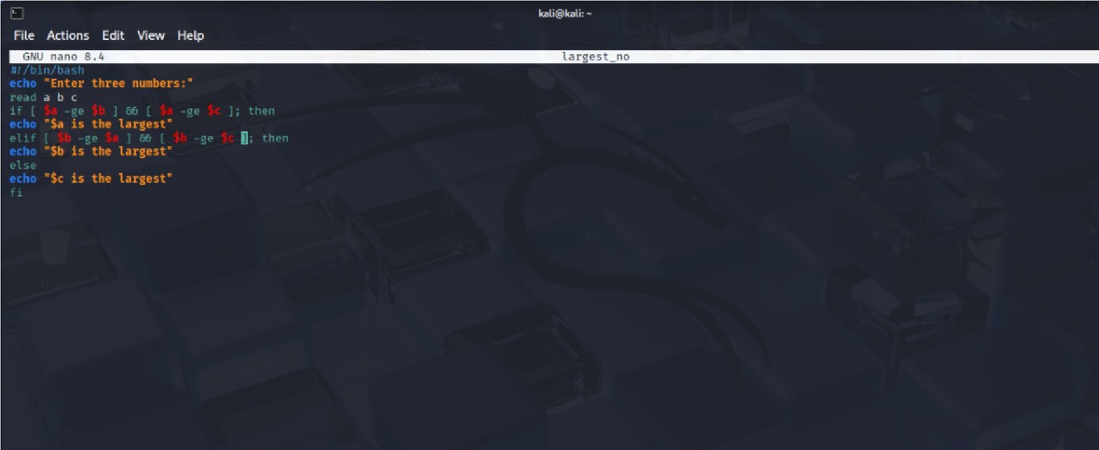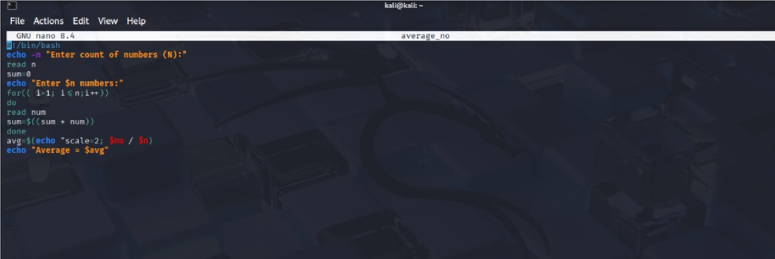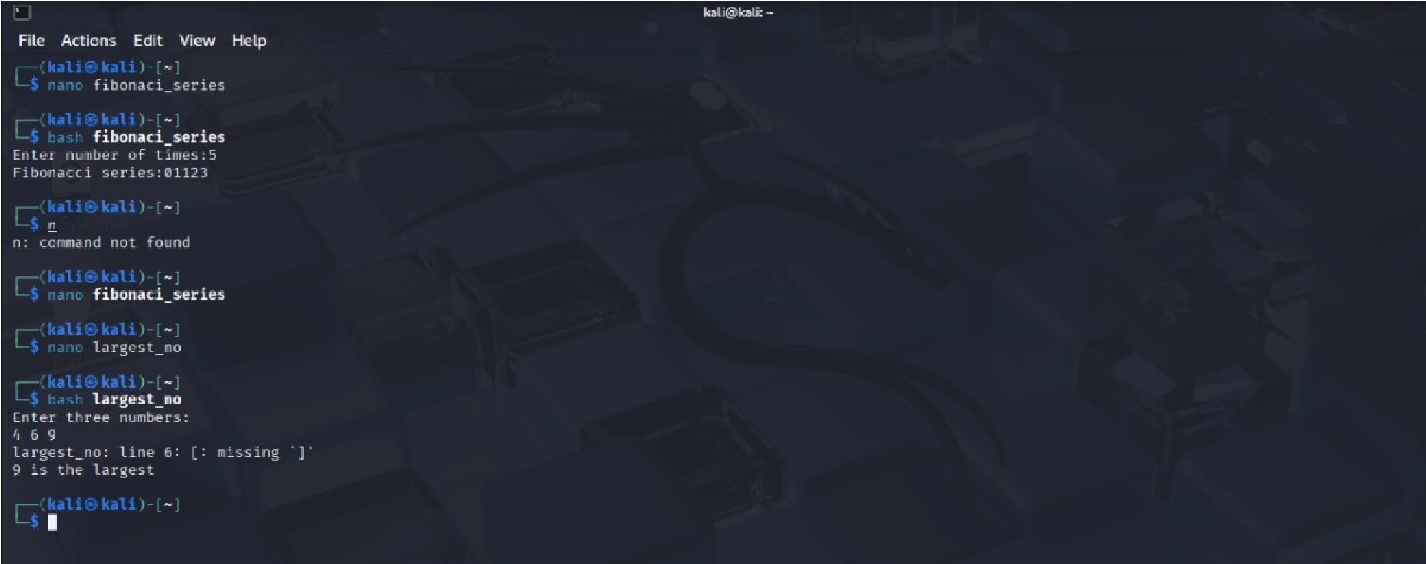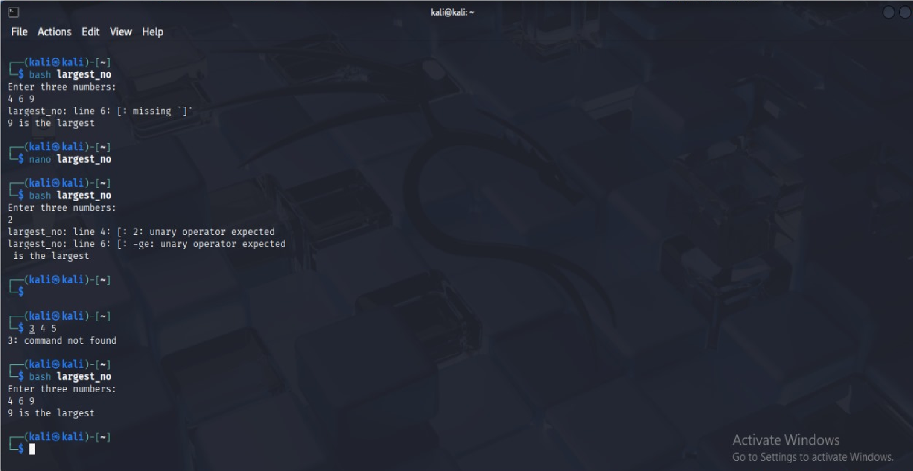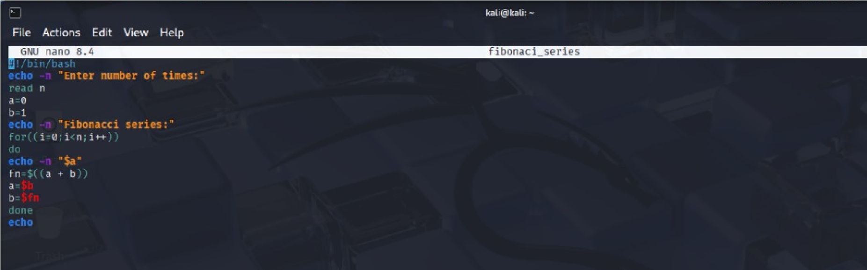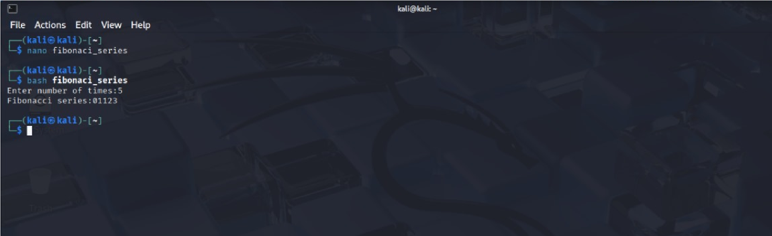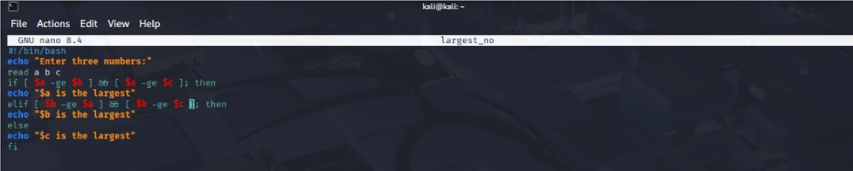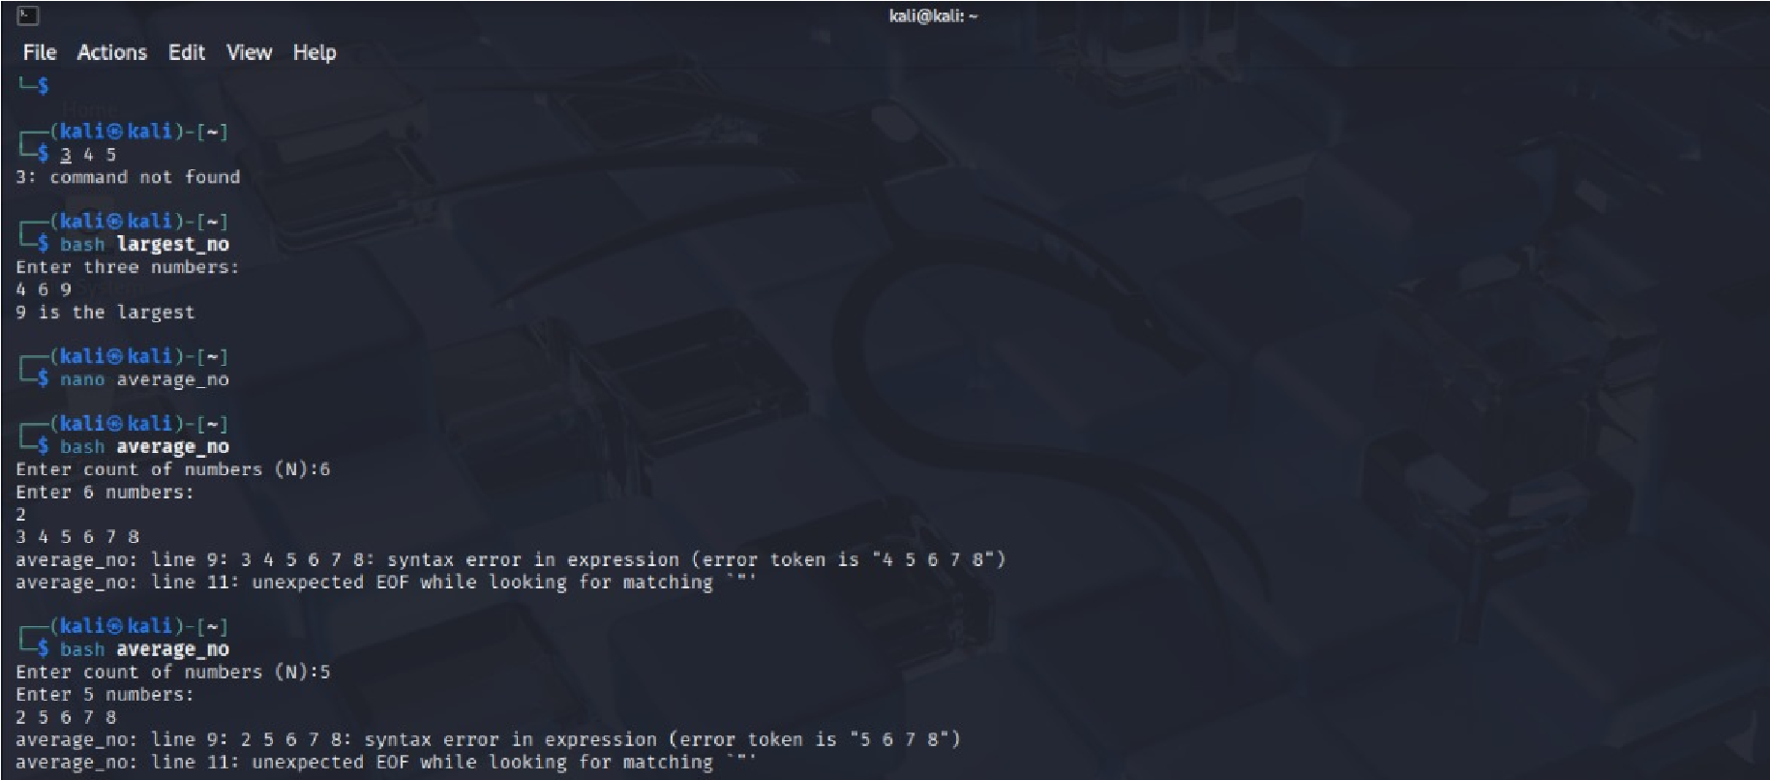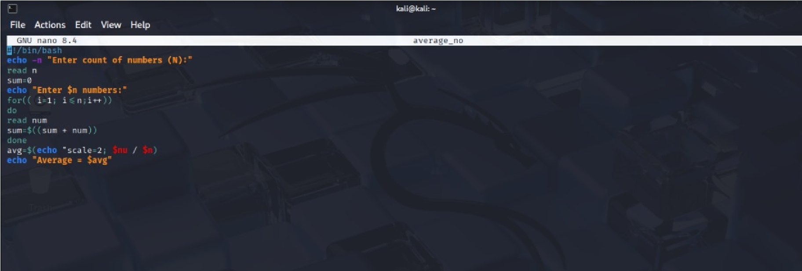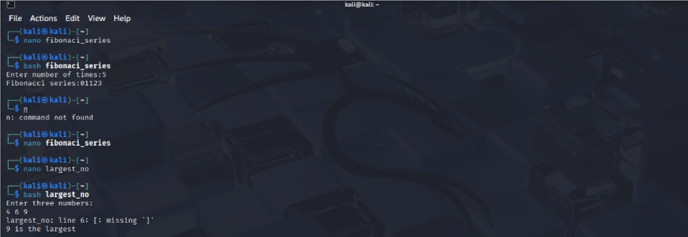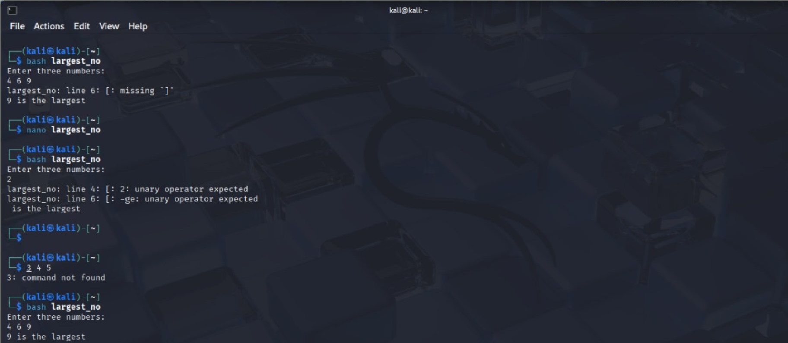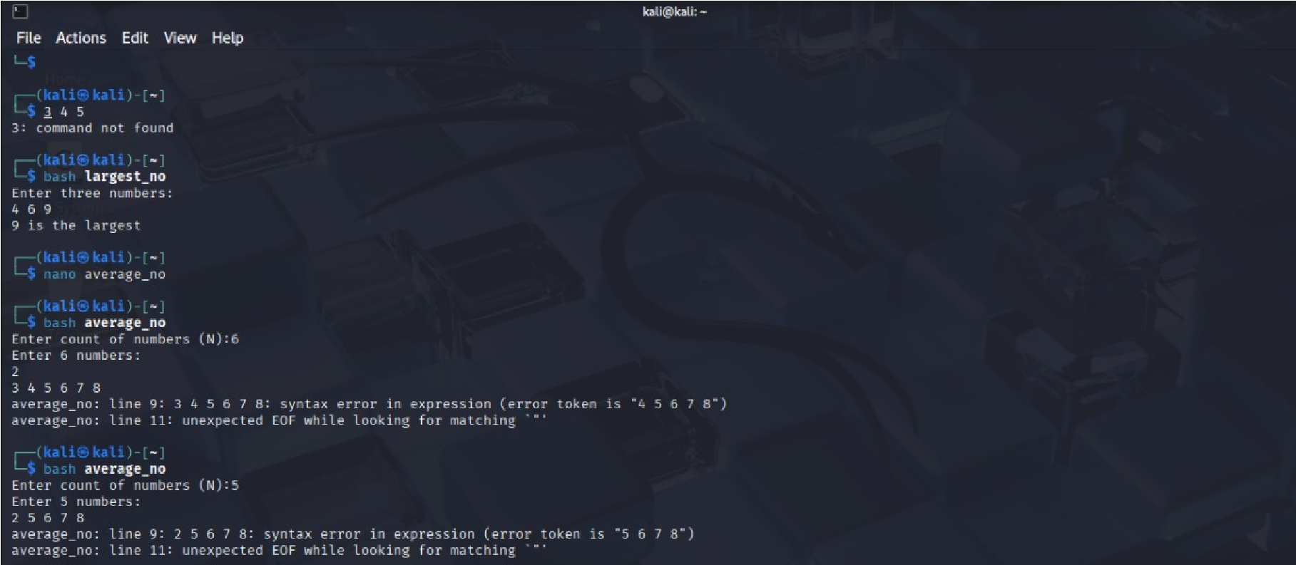

## EXPERIMENT NO. 4

|  |
| --- |
| **Student Name and Roll Number: Kunal sharma23csu396** |
| **Semester /Section: 5th / Data Science A** |
| **Link to Code:** |
| **Date: 25/08/25** |
| **Faculty Signature: Dr. Asha Sohal** |
| **Marks:** |
| **Objective:**  To write the shell programming code for the following. | |
| **Outcome:**  Student is able to write code in shell programming | |
| **Problem Statement:**   1. Write a shell program to check whether a number is even or odd 2. Write a shell program to find whether a number is prime or not. 3. Write a shell program to find whether a number is palindrome or not. 4. Write a shell program to type number 1 to 7 and then print its corresponding day of week | |
| **Background Study:**  A shell script is a file with a set of commands in it. The shell reads this file and executes the instructions as if they were input directly on the command line.  A shell is a command-line interpreter and operations such as file manipulation, program execution and text printing is performed by shell script. So, we will use vi editor to edit our files. | |
| **Question Bank:**   1. **What are Zoombie Process?**   **Ans A zombie process is a process that has completed execution but still has an entry in the process table. It remains until its parent reads its exit status. It doesn't consume resources but clutters the process table.**   1. **What are different types of variables used in shell script?**   **Ans Types of Variables in Shell Script**  **Local – Used within the script or function**  **Environment – Available to child processes**  **Special – Built-in (e.g., $0, $1, $?)**   1. **What are the different types of modes available in Vi editor?**   **Ans The Vi editor operates in three modes: normal mode (default, for navigating and issuing commands), insert mode (for typing and editing text), and command mode (accessed with : to save, quit, or search).**   1. **What are the different types of permission at file level in shell?**   **Ans At the file level in Linux, permissions include read (r) to view content, write (w) to modify, and execute (x) to run the file. These permissions apply separately to the owner, group, and others.**   1. **How to use comments in shell script.**   **Ans In shell scripts, comments are written using #. Anything after # on a line is ignored by the shell. For multi-line comments, a common trick is using a here document like :**  **<<'COMMENT' ... COMMENT to block out multiple lines.** | |

# Student Work Area

## Algorithm/Flowchart/Code/Sample output

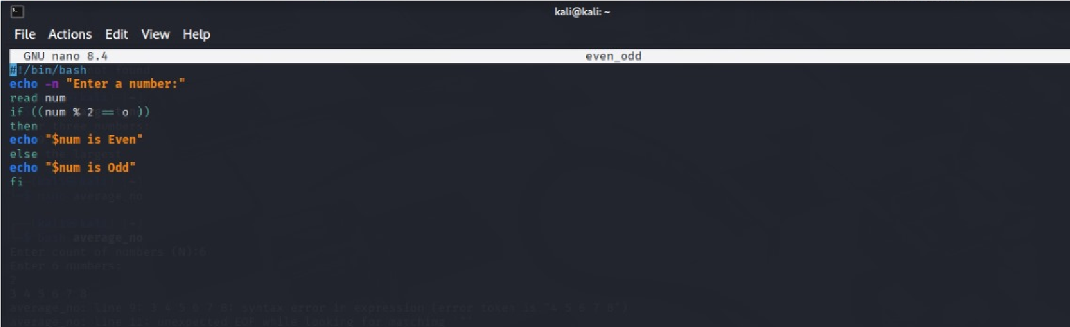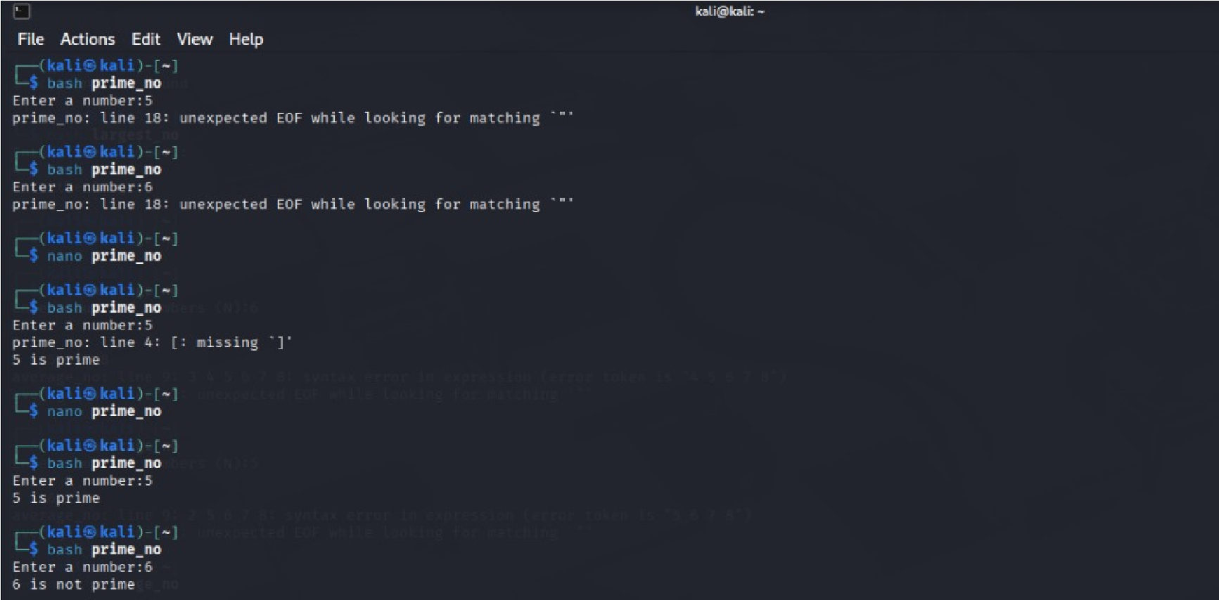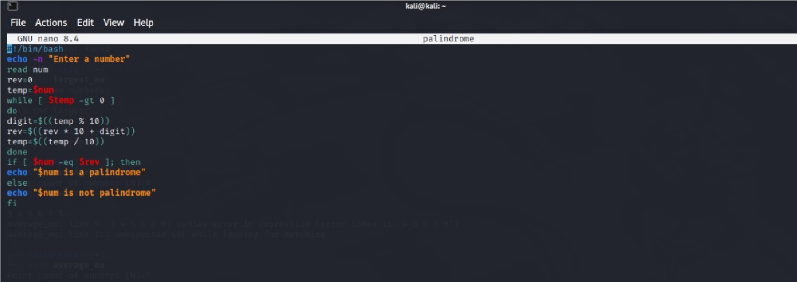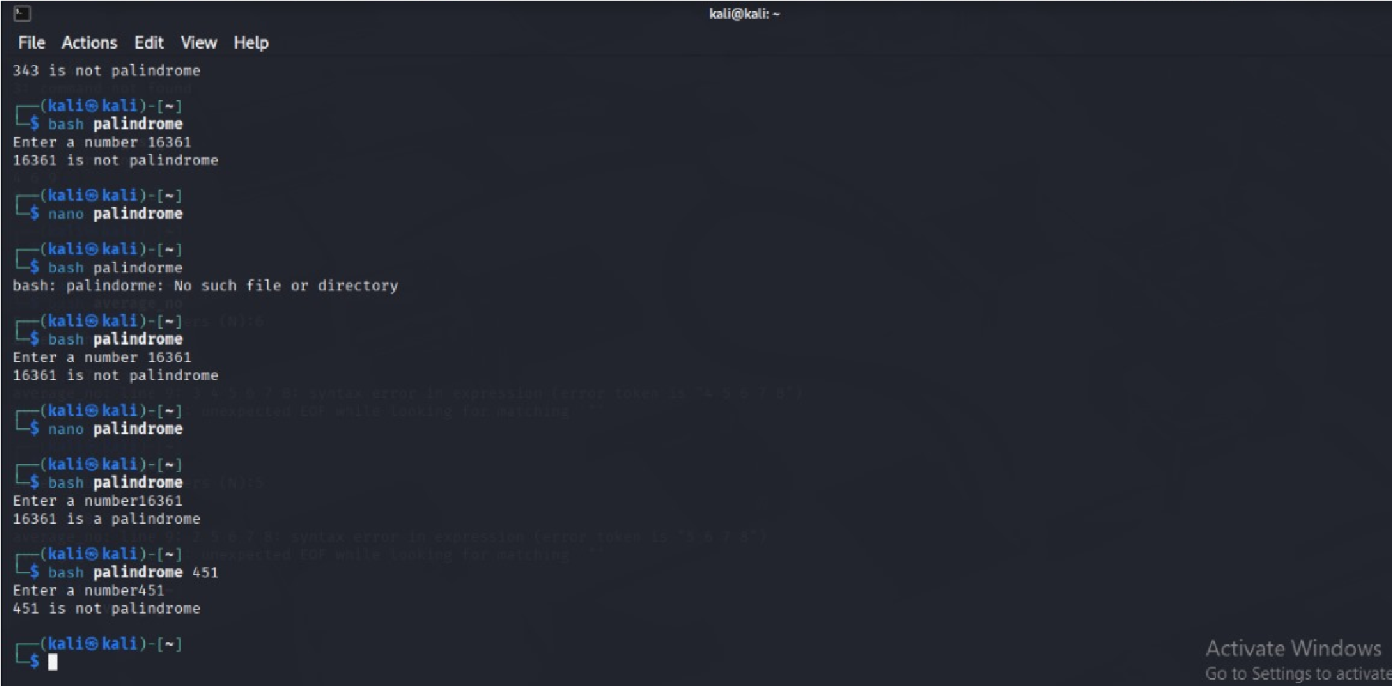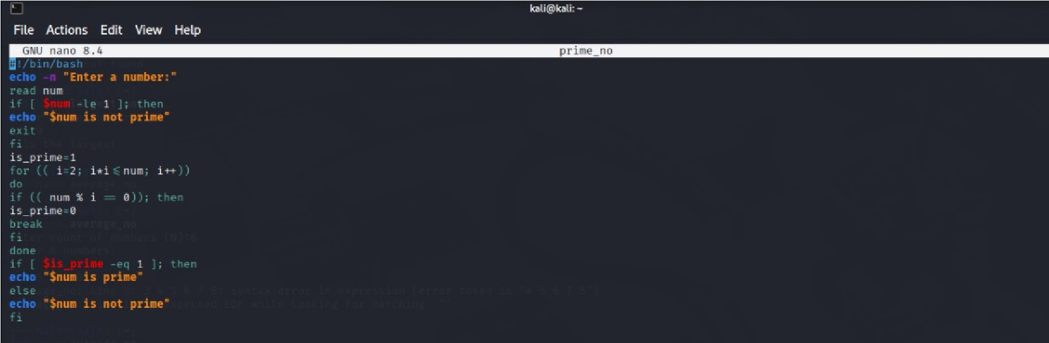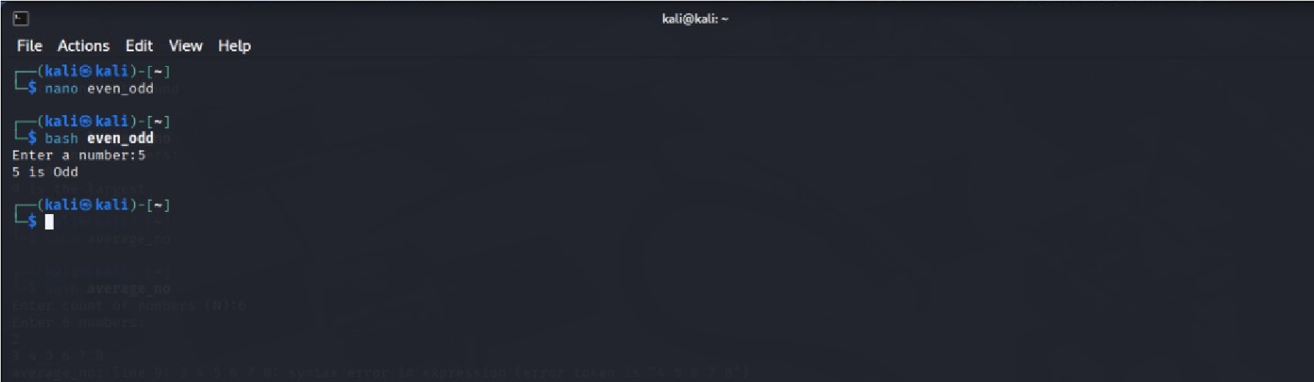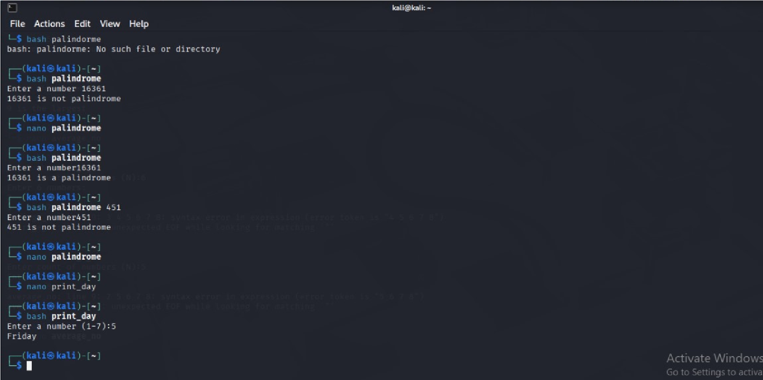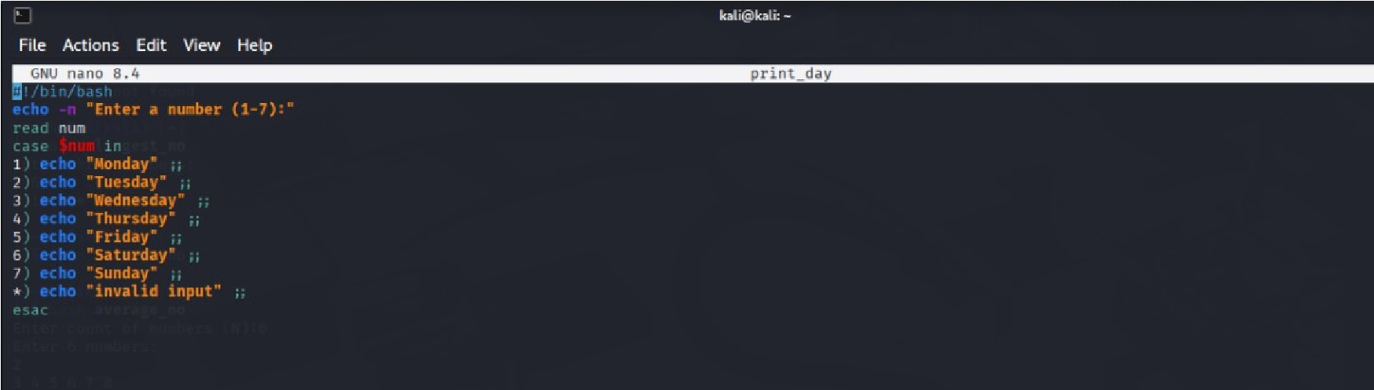

## Experiment No: 5

|  |
| --- |
| **Student Name and Roll Number: Kunal sharma 23csu396** |
| **Semester /Section: 5th / Data Science** |
| **Link to Code:** |
| **Date: 8/9/25** |
| **Faculty Signature: Dr. Asha Sohal** |
| **Marks:** |
| **Objective:**  Write a program to implement CPU scheduling for first come first serve approach. | |
| **Outcome:**  The students will understand the First-cum-first-serve algorithm | |
| **Problem Statement:**  Implement the following CPU scheduling Algorithms.  i) FCFS with Arrival time ii) FCFS without Arrival time | |
| **Background Study:**  **FCFS**   * The simplest CPU-scheduling algorithm is the first-come, first-served (FCFS) scheduling algorithm. With this algorithm, processes are assigned the CPU in the order they request it. * There is a single queue of ready processes. * The implementation of the FCFS policy is easily managed with a FIFO queue. When a process enters the ready queue, its PCB is linked onto the tail of the queue. * The average waiting time under the FCFS policy, however, is often quite long. | |
| **Question Bank:**  1. Which module gives control of the CPU to the process selected by the short-term scheduler? a) **dispatche**r   1. interrupt 2. scheduler | |

|  |  |
| --- | --- |
|  | d) none of the mentioned |
| 2. | The processes that are residing in main memory and are ready and waiting to execute are kept on a list called   1. job queue 2. **ready queue** 3. execution queue 4. process queue |
| 3. | The interval from the time of submission of a process to the time of completion is termed as a) waiting time   1. **turnaround time** 2. response time 3. throughput |
| 4. | Which scheduling algorithm allocates the CPU first to the process that requests the CPU first? **a) first-come, first-served scheduling**   1. shortest job scheduling 2. priority scheduling 3. none of the mentioned |
| 5. | In priority scheduling algorithm   1. **CPU is allocated to the process with highest priority** 2. CPU is allocated to the process with lowest priority 3. equal priority processes cannot be scheduled 4. none of the mentioned |

# Student Work Area

## Algorithm/Flowchart/Code/Sample Outputs

AIM :- Write a program to implement CPU scheduling for first come first serve approach.

1) FCFS WITH ARRIVAL TIME **SOURCE CODE**

#!/bin/bash

# FCFS Scheduling Algorithm with Arrival Time echo -n "Enter the number of processes: " read n # Arrays pid=() at=() bt=() ct=() tat=() wt=()

# Input process details for ((i=0; i<n; i++))

do

pid[$i]=$((i+1)) echo -n "Enter Arrival Time of Process $((i+1)): " read at[$i]

echo -n "Enter Burst Time of Process $((i+1)): " read bt[$i]

done

# Sort processes by arrival time (Bubble sort) for ((i=0; i<n-1; i++))

do

for ((j=i+1; j<n; j++)) do if [ ${at[$i]} -gt ${at[$j]} ]; then # swap arrival time temp=${at[$i]} at[$i]=${at[$j]} at[$j]=$temp

# swap burst time temp=${bt[$i]} bt[$i]=${bt[$j]} bt[$j]=$temp

# swap process id temp=${pid[$i]} pid[$i]=${pid[$j]} pid[$j]=$temp

fi

done

done

# Calculate Completion, Turnaround, Waiting times ct[0]=$(( at[0] + bt[0] )) for ((i=1; i<n; i++))

do

if [ ${at[$i]} -gt ${ct[$i-1]} ]; then ct[$i]=$(( at[$i] + bt[$i] )) # CPU idle till this process arrives else ct[$i]=$(( ct[$i-1] + bt[$i] ))

fi

done

for ((i=0; i<n; i++))

do

tat[$i]=$(( ct[$i] - at[$i] )) wt[$i]=$(( tat[$i] - bt[$i] ))

done

# Display results echo "" echo "PID AT BT CT TAT WT" for ((i=0; i<n; i++))

do

echo "P${pid[$i]} ${at[$i]} ${bt[$i]} ${ct[$i]} ${tat[$i]} ${wt[$i]}"

done

# Calculate averages total_wt=0 total_tat=0 for ((i=0; i<n; i++))

do

total_wt=$(( total_wt + wt[$i] )) total_tat=$(( total_tat + tat[$i] ))

done

# Integer division for averages avg_wt=$(( total_wt / n )) avg_tat=$(( total_tat / n ))

echo "" echo "Average Waiting Time: $avg_wt" echo "Average Turnaround Time: $avg_tat"

### OUTPUT

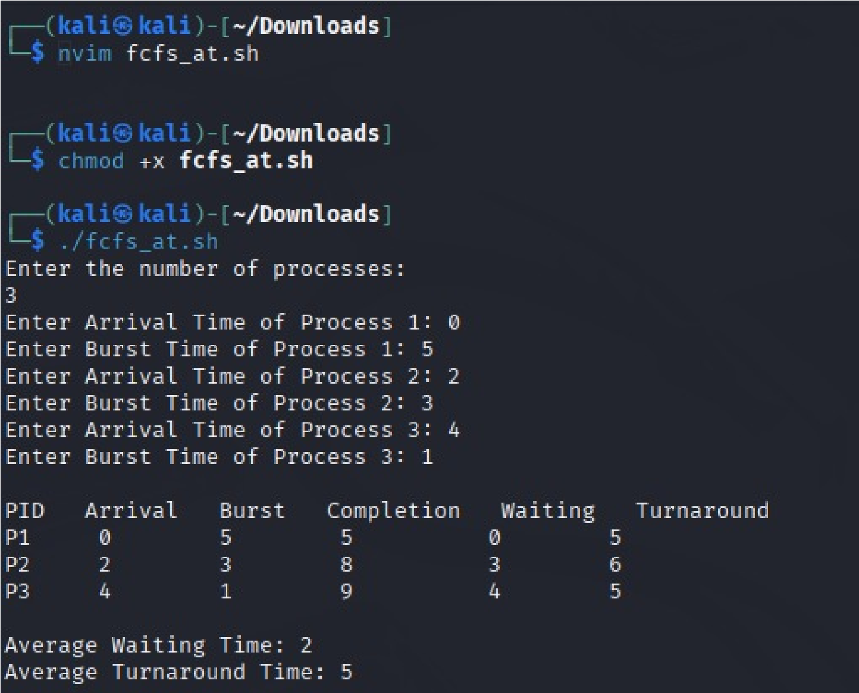

2) FCFS WITHOUT ARRIVAL TIME

### Source Code

#!/bin/bash

# FCFS Scheduling Algorithm in Shell Script echo "Enter the number of processes:" read n

# Arrays for burst time, waiting time, turnaround time bt=() wt=()

tat=() # Input burst times echo "Enter the burst time for each process:" for ((i=0; i<n; i++))

do

echo -n "Burst Time of Process $((i+1)): " read bt[$i]

done

# Calculate waiting time wt[0]=0

for ((i=1; i<n; i++))

do

wt[$i]=$(( ${wt[$i-1]} + ${bt[$i-1]} ))

done

# Calculate turnaround time

for ((i=0; i<n; i++))

do

tat[$i]=$(( ${wt[$i]} + ${bt[$i]} ))

done

# Display results echo ""

echo "Process Burst Time Waiting Time Turnaround Time" for ((i=0; i<n; i++))

do

echo "P$((i+1)) ${bt[$i]} ${wt[$i]} ${tat[$i]}"

done

# Calculate average waiting time and turnaround time total_wt=0 total_tat=0 for ((i=0; i<n; i++))

do

total_wt=$(( total_wt + ${wt[$i]} )) total_tat=$(( total_tat + ${tat[$i]} ))

done

avg_wt=$(echo "scale=2; $total_wt / $n" | bc) avg_tat=$(echo "scale=2; $total_tat / $n" | bc)

echo "" echo "Average Waiting Time: $avg_wt" echo "Average Turnaround Time: $avg_tat"

### OUTPUT

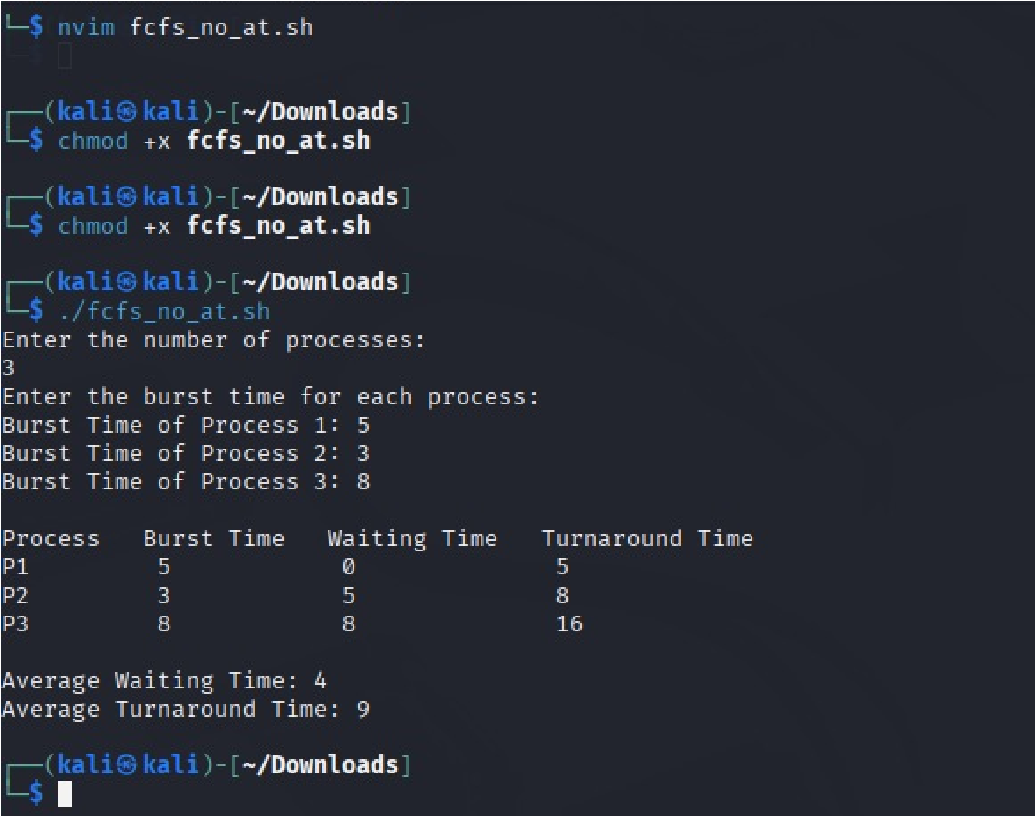

## Experiment No: 6

|  |  |
| --- | --- |
| **Student Name and Roll Number: Kunal sharma23csu396** | |
| **Semester /Section: 5th / Data Science A** | |
| **Link to Code:** | |
| **Date: 8/09/25** | |
| **Faculty Signature: Dr. Asha Sohal** | |
| **Marks:** | |
| **Objective:**  Write a program to implement CPU scheduling for shortest job first (Preemptive and Non-Preemptive) | | |
| **Outcome:**  The students will understand the Shortest Job First scheduling mechanism | | |
| **Problem Statement:**  Implement the following CPU scheduling Algorithms.   * SJF (Non-Preemptive) * SJTF (shortest remaining time first -Preemptive SJF) | | |
| **Background Study:**   * Shortest Job first is having the advantage of a minimum average waiting time . * This algorithm associates with each process the length of the process next burst time.When CPU is available it assigned to the process that has the smallest next CPU burst time.if CPU burst time of two process is same then it follows FCFS. * It may cause starvation if shorter processes keep coming. This problem can be solved using the concept of ageing. * It is practically infeasible as Operating System may not know burst time and therefore may not sort them. | | |
| **Question Bank:**   1. [scheduling algorithm](https://t4tutorials.com/round-robin-process-scheduling-algorithm-in-operating-systems/) In multilevel feedback    1. processes are not classified into groups    2. **a process can move to a different classified ready queue…**    3. classification of the ready queue is permanent    4. none of the mentioned 2. Select one which algorithms tend to minimize the process flow time?    1. First come First served | | |
|  | 1. Earliest Deadline First 2. **Shortest Job First** 3. Longest Job First | |
| 3. | The process can be classified into many groups in   1. [shortest job scheduling algorithm](https://t4tutorials.com/shortest-job-first-scheduling-sjf-process-scheduling-in-operating-systems/) 2. **multilevel queue scheduling algorithm** 3. round-robin scheduling algorithm 4. priority scheduling algorithm | |
| 4. | The turnaround time for short jobs during multiprogramming is usually Shortened and that for long jobs is slightly ___________   1. Shortened 2. Unchanged 3. **Lengthened** 4. Shortened | |
| 5. | Time quantum can be said   1. multilevel queue scheduling algorithm 2. **round-robin scheduling algorithm** 3. shortest job scheduling algorithm 4. priority scheduling algorithm | |

# Student Work Area

## Algorithm/Flowchart/Code/Sample Outputs

Program to implement CPU scheduling for shortest job first (Preemptive and Non-Preemptive)

### Source Code (SJF NON PREEMPTIVE)

#!/bin/bash echo "Enter number of processes:"; read n pid=(); at=(); bt=(); ct=(); wt=(); tat=(); donep=()

for ((i=0;i<n;i++)); do pid[$i]=$((i+1)); read -p "AT of P$((i+1)): " at[$i]; read -p "BT of P$((i+1)): " bt[$i]; done time=0; comp=0 while [ $comp -lt $n ]; do min=9999; idx=-1

for ((i=0;i<n;i++)); do if [ ${at[i]} -le $time ] && [[ ! " ${donep[@]} " =~ " $i " ]]; then if [

${bt[i]} -lt $min ]; then min=${bt[i]}; idx=$i; fi; fi; done

if [ $idx -eq -1 ]; then time=$((time+1)); else time=$((time+bt[idx])); ct[$idx]=$time; tat[$idx]=$((ct[idx]-at[idx])); wt[$idx]=$((tat[idx]-bt[idx])); donep+=($idx); comp=$((comp+1)); fi done echo "PID AT BT CT WT TAT" tw=0; tt=0

for ((i=0;i<n;i++)); do echo "P${pid[i]} ${at[i]} ${bt[i]} ${ct[i]} ${wt[i]} ${tat[i]}"; tw=$((tw+wt[i])); tt=$((tt+tat[i])); done echo "Avg WT=$((tw/n))" echo "Avg TAT=$((tt/n))"

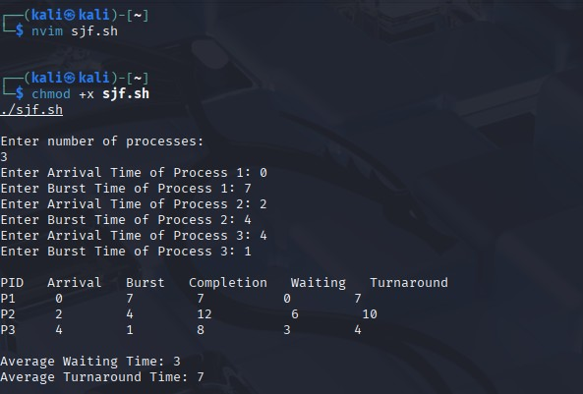

**Source Code (**SJTF (shortest remaining time first -Preemptive SJF)**)**

#!/bin/bash echo "Enter number of processes:"; read n pid=(); at=(); bt=(); rem=(); ct=(); wt=(); tat=()

for ((i=0;i<n;i++)); do pid[$i]=$((i+1)); read -p "AT of P$((i+1)): " at[$i]; read -p "BT of P$((i+1)): " bt[$i]; rem[$i]=${bt[$i]}; done time=0; comp=0 while [ $comp -lt $n ]; do min=9999; idx=-1

for ((i=0;i<n;i++)); do if [ ${at[i]} -le $time ] && [ ${rem[i]} -gt 0 ]; then if [ ${rem[i]} -lt

$min ]; then min=${rem[i]}; idx=$i; fi; fi; done

if [ $idx -eq -1 ]; then time=$((time+1)); else rem[$idx]=$((rem[idx]-1)); time=$((time+1)); if [ ${rem[idx]} -eq 0 ]; then ct[$idx]=$time; tat[$idx]=$((ct[idx]-at[idx])); wt[$idx]=$((tat[idx]-bt[idx])); comp=$((comp+1)); fi; fi done echo "PID AT BT CT WT TAT" tw=0; tt=0

for ((i=0;i<n;i++)); do echo "P${pid[i]} ${at[i]} ${bt[i]} ${ct[i]} ${wt[i]} ${tat[i]}"; tw=$((tw+wt[i])); tt=$((tt+tat[i])); done echo "Avg WT=$((tw/n))" echo "Avg TAT=$((tt/n))"

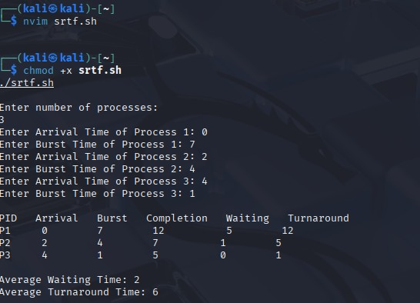

## Experiment No: 7

|  |
| --- |
| **Student Name and Roll Number: Kunal sharma 23csu396** |
| **Semester /Section: 5TH / Data Science A** |
| **Link to Code:** |
| **Date: 8/09/25** |
| **Faculty Signature: Dr. Asha Sohal** |
| **Marks:** |
| **Objective:**  Write a program to perform priority scheduling among a set of processes. | |
| **Outcome:**  Student will understand the working of priority scheduling among a set of processes. | |
| **Problem Statement:**  Implement the priority scheduling. | |
| **Background Study:**  Priority scheduling is a non-preemptive algorithm and used in batch systems. Each process is assigned a priority. Process with highest priority is to be executed first and so on. | |
| **Question Bank:**   1. What are advantages of Priority scheduling?   **Sol.** **Easy to use scheduling method. Processes are executed on the basis of priority so high priority does not need to wait for long which saves time.**   1. What are disadvantages of priority scheduling?   **Sol.** **The major disadvantage of priority scheduling is the process of indefinite blocking or starvation. This problem appears when a process is ready to be executed but it has to wait for the long time for execution by CPU because other high priority processes are executed by the CPU.**   1. At the ready queue when a process arrives In [priority scheduling](https://t4tutorials.com/priority-based-process-scheduling-in-operating-systems/) algorithm, the priority of this process is compared with the priority of?    1. **currently running process**    2. parent process    3. all process | |
| D. init process  4. Differentiate between pre-emptive and non pre-emptive scheduling?  **Sol. The basic difference between preemptive and non-preemptive scheduling is that in preemptive scheduling the CPU is allocated to the processes for the limited time. While in Non-preemptive scheduling, the CPU is allocated to the process till it terminates or switches to waiting state.** | |

# Student Work Area

## Algorithm/Flowchart/Code/Sample Outputs

Program to perform priority scheduling among a set of processes.

**Source Code** #!/bin/bash echo "Enter number of processes:"; read n pid=(); bt=(); prio=(); ct=(); wt=(); tat=()

for ((i=0;i<n;i++)); do pid[$i]=$((i+1)); read -p "BT of P$((i+1)): " bt[$i]; read -p "Priority of P$((i+1)): " prio[$i]; done

for ((i=0;i<n-1;i++)); do for ((j=0;j<n-i-1;j++)); do if [ ${prio[j]} -gt ${prio[j+1]} ]; then t=${prio[j]}; prio[j]=${prio[j+1]}; prio[j+1]=$t; t=${bt[j]}; bt[j]=${bt[j+1]}; bt[j+1]=$t; t=${pid[j]}; pid[j]=${pid[j+1]}; pid[j+1]=$t; fi; done; done ct[0]=${bt[0]} for ((i=1;i<n;i++)); do ct[$i]=$((ct[i-1]+bt[i])); done for ((i=0;i<n;i++)); do tat[$i]=${ct[i]}; wt[$i]=$((tat[i]-bt[i])); done echo "PID BT Priority CT WT TAT" tw=0; tt=0

for ((i=0;i<n;i++)); do echo "P${pid[i]} ${bt[i]} ${prio[i]} ${ct[i]} ${wt[i]} ${tat[i]}"; tw=$((tw+wt[i])); tt=$((tt+tat[i])); done echo "Avg WT=$((tw/n))"

echo "Avg TAT=$((tt/n))"

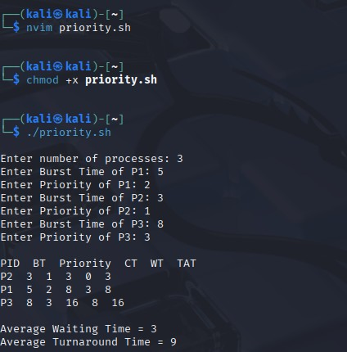

## Experiment No: 8

|  |
| --- |
| **Student Name and Roll Number: Kunal sharma 23csu396** |
| **Semester /Section: 5th / Data Science A** |
| **Link to Code:** |
| **Date: 15/09/25** |
| **Faculty Signature: Dr. Asha Sohal** |
| **Marks:** |
| **Objective: Objective**  To familiarize the students about CPU scheduling Algorithms | |
| **Program Outcome**  The students will understand the Round Robin Algorithm. | |
| **Problem Statement:**  Implement the Round Robin Algorithm. | |
| **Background Study:**  • In Round Robin each process is assigned a fixed time slot in a cyclic way and this is preemptive. It has a disadvantage of context switch and have quantum time | |
| **Question Bank:**  1. What is Preemptive and Non- Preemptive CPU scheduling? Explain with examples.  **Sol.Preemptive:**  **In this resources(CPU Cycle) are allocated to a process for a limited time.**  **Eg. Examples of preemptive scheduling are Round Robin and Shortest Remaining Time First.**  **Non-Preemptive**  **Once resources(CPU Cycle) are allocated to a process, the process holds it till it completes its burst time or switches to waiting state.**  **Eg. Examples of non-preemptive scheduling are First Come First Serve and Shortest Job First.** | |

|  |
| --- |
| 1. Explain the difference between short term, long term and medium term scheduling. **Sol.Long term: It selects processes from the pool and load them into memory for execution.**   **Medium term: Process can be reintroduced into the meat and its execution can be continued.**  **Short term: It selects from among the processes that are ready to execute.**   1. Explain the function of Dispatcher and Context Switch mechanism.   **Sol. Dispatcher is also responsible for:Context Switching, Switch to user mode, Jumping to proper location when process again restarted**  **The only work of scheduler is selection of processes.**   1. What are the advantages and disadvantages of Round robin?   **Sol. Advantages –**  **Every process gets an equal share of the CPU.**  **RR is cyclic in nature, so there is no starvation.**  **Disadvantages –**  **Setting the quantum too short, increases the overhead and lowers the CPU efficiency, but setting it too long may cause poor response to short processes.**  **Average waiting time under the RR policy is often long.**  **5.** Give the application are of Robin Robin.  **Sol.** **A popular use of the queue data structure is the scheduling problem in the operating system. Round-robin is one of the simplest scheduling algorithms for processes in an operating system, which assigns time slices to each process in equal portions and in order, handling all processes without priority.** |

# Student Work Area

**Algorithm/Flowchart/Code/Sample Outputs**

To familiarize the students about CPU scheduling Algorithms

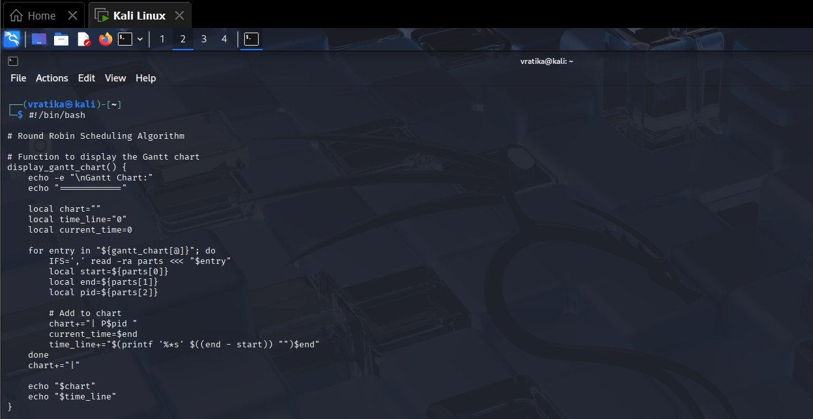

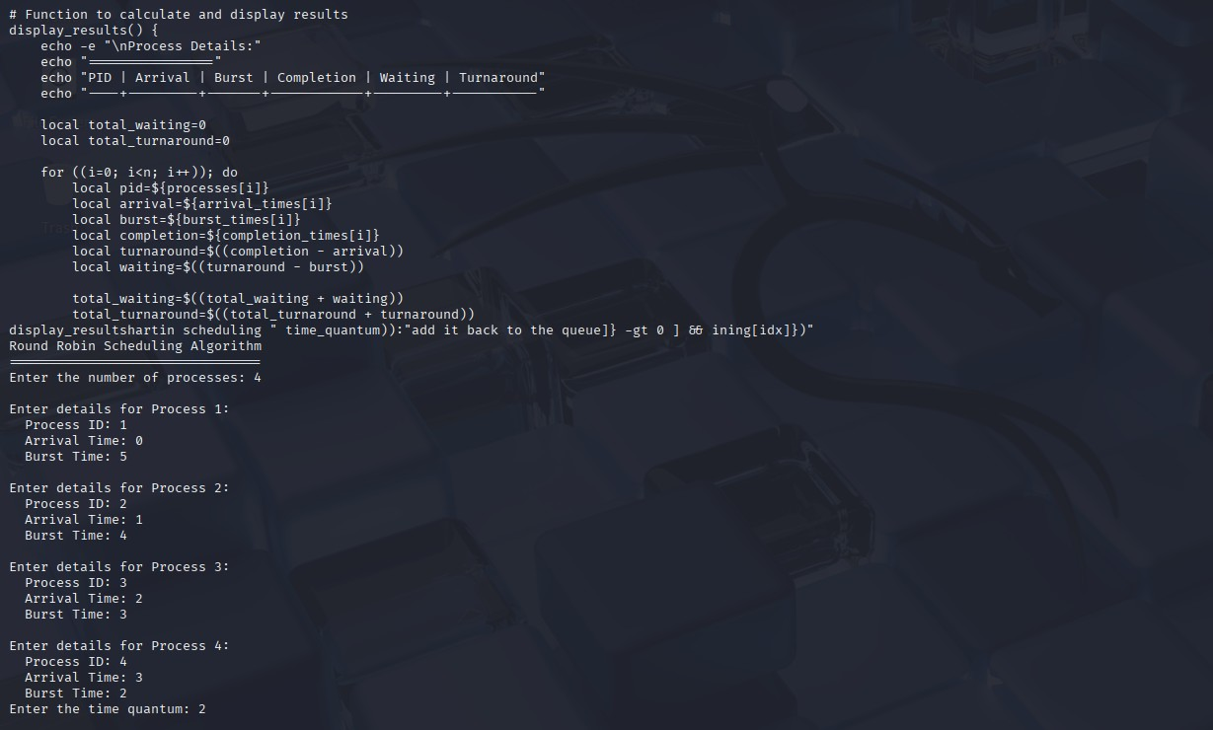

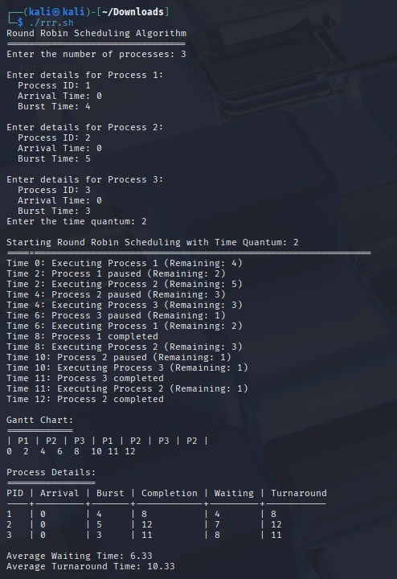

## Experiment No: 9

|  |  |
| --- | --- |
| **Student Name and Roll Number: Kunal sharma 23csu396** | |
| **Semester /Section: 5th / Data Science A** | |
| **Link to Code:** | |
| **Date: 6/10/25** | |
| **Faculty Signature: Dr Asha Sohal** | |
| **Marks:** | |
| **Objective:** Write a program to implement reader/writer problem using semaphore | | |
| **Program Outcome**  The students will understand the reader/writer problem using semaphore | | |
| **Problem Statement:**  Write a program to implement reader/writer problem using semaphore | | |
| **Background Study:** There is a shared resource which should be accessed by multiple processes. There are two types of processes in this context. They are reader and writer. Any number of readers can read from the shared resource simultaneously, but only one writer can write to the shared resource. When a writer is writing data to the resource, no other process can access the resource. A writer cannot write to the resource if there are non-zero number of readers accessing the resource at that time. | | |
| **Question Bank:**   1. An un-interruptible unit is known as ____________ a) single    1. **atomic**    2. static    3. none of the mentioned 2. TestAndSet instruction is executed ____________    1. after a particular process    2. periodically    3. **atomically**    4. none of the mentioned 3. Semaphore is a/an _______ to solve the critical section problem.    1. hardware for a system    2. special program for a system | | |
|  | 1. **integer variable** 2. none of the mentioned | |
| **4.** | What are the two atomic operations permissible on semaphores? **a) wait**   1. stop 2. hold 3. none of the mentioned | |
| **5.** | When several processes access the same data concurrently and the outcome of the execution depends on the particular order in which the access takes place is called ________ a) dynamic condition   1. **race condition** 2. essential condition 3. critical condition | |

# Student Work Area

**Algorithm/Flowchart/Code/Sample Outputs**

Write a program to implement reader/writer problem using semaphore

## Code

#!/bin/bash

# Shared resource shared_data=0

# Mutex simulation using a lock file lockfile="/tmp/reader_writer.lock" # Create lock file if it doesn't exist touch $lockfile

# Function for reader reader() { id=$1 for i in {1..5}; do echo "Reader $id is waiting to read..." sleep 1 # simulate waiting

# Acquire read lock (simulate using lock file) exec 200>"$lockfile" flock -s 200 # shared lock for readers

echo "Reader $id: read shared_data = $shared_data" sleep 1 # simulate reading

flock -u 200 # release lock sleep 1 done

}

# Function for writer writer() { id=$1 for i in {1..5}; do echo "Writer $id is waiting to write..." sleep 2 # simulate waiting

# Acquire write lock (exclusive) exec 200>"$lockfile" flock -x 200 # exclusive lock for writer

shared_data=$((shared_data + 1)) echo "Writer $id: wrote shared_data = $shared_data" sleep 2 # simulate writing

flock -u 200 # release lock sleep 1 done

}

# Start readers and writers in background reader 1 & reader 2 & writer 1 & reader 3 & writer 2 &

# Wait for all background processes to finish wait

echo "Simulation complete. Final shared_data = $shared_data"

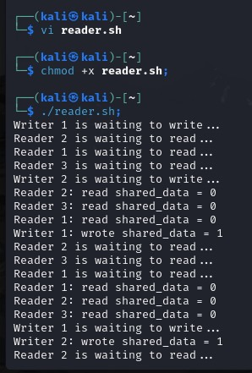

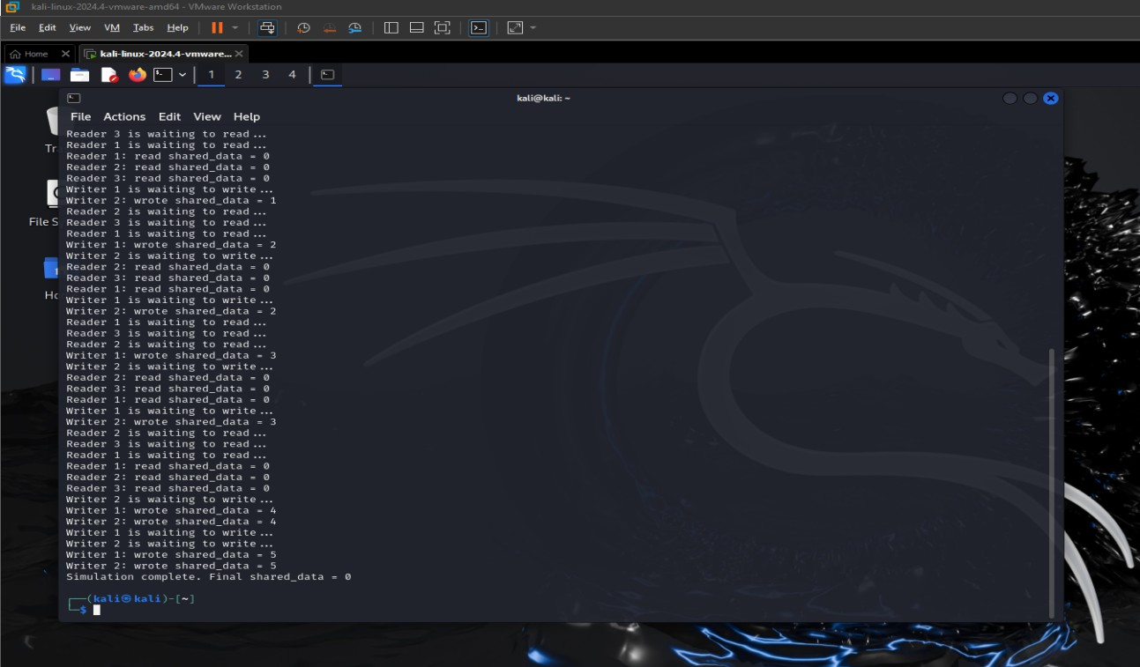

## Experiment No: 10

|  |  |
| --- | --- |
| **Student Name and Roll Number: Kunal sharma 23csu396** | |
| **Semester /Section: 5th / Data Science A** | |
| **Link to Code:** | |
| **Date: 6/10/2025** | |
| **Faculty Signature: Dr. Asha Sohal** | |
| **Marks:** | |
| **Objective:**  Write a program to implement Dining Philosopher’s problem using semaphore | | |
| **Outcome:**  The students will understand the problem of synchronization among processes and its solution through  Dining Philosopher’s problem using semaphore | | |
| **Problem Statement:**  Write a program to implement Dining Philosopher’s problem using semaphore | | |
| **Background Study:**  Five philosophers, spend their time thinking and eating spaghetti. They eat at a round table with five individual seats. For eating each philosopher needs two forks (the resources). There are five forks on the table, one left and one right of each seat. When a philosopher cannot grab both forks it sits and waits. Eating takes random time, then the philosopher puts the forks down and leaves the dining room. After spending some random time thinking he again becomes hungry, and the circle repeats itself. | | |
| **Question Bank:**   1. Which one of the following is a synchronization tool? a) thread    1. pipe    2. **semaphore**    3. socket 2. A semaphore is a shared integer variable __________    1. **that can not drop below zero**    2. that can not be more than zero    3. that can not drop below one | | |
|  | d) that can not be more than one | |
| 3. | The bounded buffer problem is also known as ____________ a) Readers – Writers problem   1. Dining – Philosophers problem 2. **Producer – Consumer problem** 3. None of the mentioned | |
| 4. | In the bounded buffer problem ____________ a) there is only one buffer   1. **there are n buffers ( n being greater than one but finite)** 2. there are infinite buffers 3. the buffer size is bounded | |
| **5.** | To ensure difficulties do not arise in the readers – writers problem _______ are given exclusive access to the shared object. a) readers   1. **writers** 2. readers and writers 3. none of the mentioned | |

# Student Work Area

## Algorithm/Flowchart/Code/Sample Outputs

Write a program to implement Dining Philosopher’s problem using semaphore

**Code**

#!/bin/bash

NUM_PHIL=5

# Create chopstick files (semaphores) for ((i=0; i<$NUM_PHIL; i++)); do touch "chopstick_$i" done

philosopher() {

id=$1 left=$id right=$(( (id + 1) % NUM_PHIL ))

while true do echo "Philosopher $id is thinking " sleep $((RANDOM % 3 + 1))

echo "Philosopher $id is hungry "

# Try to pick up chopsticks while [ ! -w "chopstick_$left" ]; do sleep 1; done exec {left_fd}>chopstick_$left || exit 1

while [ ! -w "chopstick_$right" ]; do sleep 1; done exec {right_fd}>chopstick_$right || exit 1

echo "Philosopher $id is eating " sleep $((RANDOM % 3 + 1))

# Release chopsticks exec {left_fd}>& exec {right_fd}>& echo "Philosopher $id finished eating and put down chopsticks "

sleep $((RANDOM % 3 + 1))

done

}

# Start all philosophers in background for ((i=0; i<$NUM_PHIL; i++)); do philosopher $i & done

# Keep the script running wait

**Output**

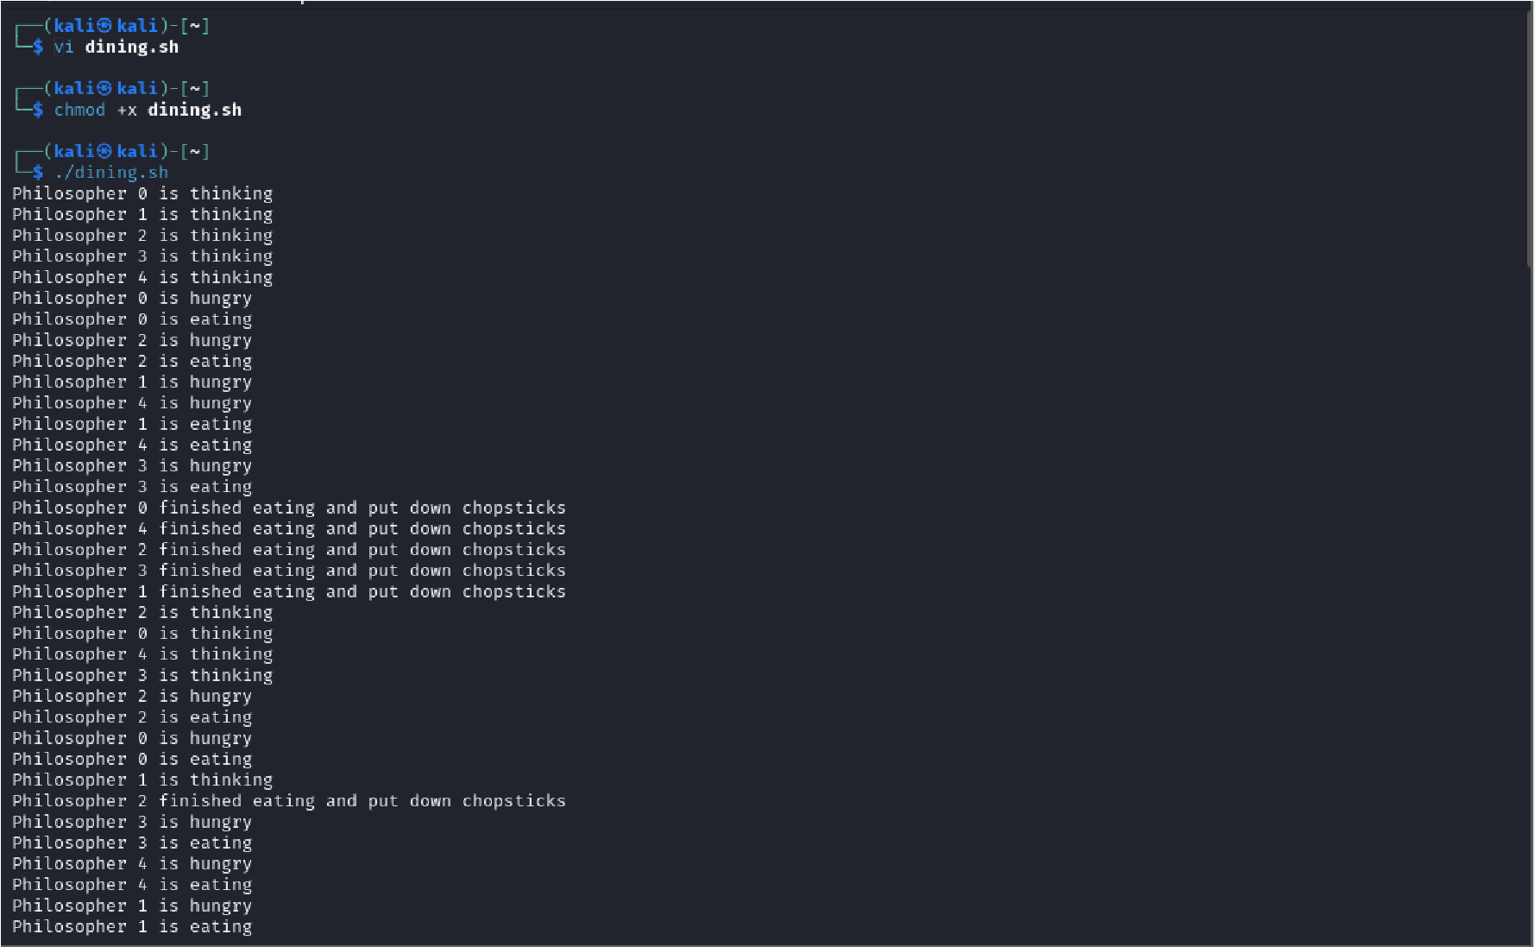

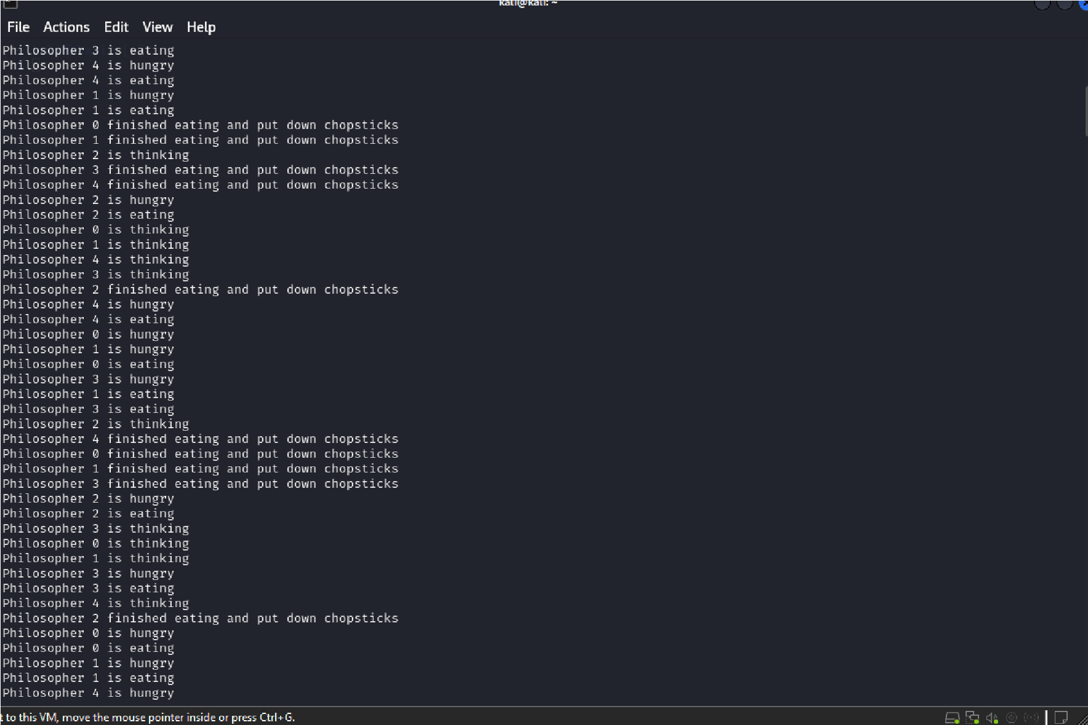

## Experiment No:11

|  |  |
| --- | --- |
| **Student Name and Roll Number: Kunal sharma 23csu396** | |
| **Semester /Section: 5th / Data Science A** | |
| **Link to Code:** | |
| **Date: 27/10/25** | |
| **Faculty Signature: Dr Asha Sohal** | |
| **Marks:** | |
| **Objective:**  Write a program to implement Banker’s algorithm for deadlock avoidance. | | |
| **Outcome:**  The students will understand how system handles deadlock using Banker’s algorithm for deadlock avoidance | | |
| **Problem Statement:**  Write a program to implement Banker’s algorithm for deadlock avoidance. | | |
| **Background Study:**  The banker’s algorithm is a resource allocation and deadlock avoidance algorithm that tests for safety by simulating the allocation for predetermined maximum possible amounts of all resources, then makes an “sstate” check to test for possible activities, before deciding whether allocation should be allowed to continue. Banker’s algorithm is named so because it is used in banking system to check whether loan can be sanctioned to a person or not. Suppose there are n number of account holders in a bank and the total sum of their money is S. If a person applies for a loan then the bank first subtracts the loan amount from the total money that bank has and if the remaining amount is greater than S then only the loan is sanctioned. It is done because if all the account holders comes to withdraw their money then the bank can easily do it. | | |
| **Question Bank:**   1. Each request requires that the system consider the _____________ to decide whether the current request can be satisfied or must wait to avoid a future possible deadlock. a) resources currently available    1. processes that have previously been in the system    2. resources currently allocated to each process    3. **future requests and releases of each process** 2. Given a priori information about the ________ number of resources of each type that maybe requested for each process, it is possible to construct an algorithm that ensures that the system will never enter a deadlock state. a) minimum    1. average | | |
|  | 1. **maximum** 2. approximate | |
| 3. | A deadlock avoidance algorithm dynamically examines the __________ to ensure that a circular wait condition can never exist. **a) resource allocation state**   1. system storage state 2. operating system 3. resources | |
| 4. | A state is safe, if ____________   1. the system does not crash due to deadlock occurrence 2. **the system can allocate resources to each process in some order and still avoid a deadlock** 3. the state keeps the system protected and safe 4. all of the mentioned | |
| 5. | The two ways of aborting processes and eliminating deadlocks are ____________ a) Abort all deadlocked processes   1. Abort all processes 2. Abort one process at a time until the deadlock cycle is eliminated 3. **All of the mentioned** | |

# Student Work Area

**Algorithm/Flowchart/Code/Sample Outputs**

Write a program to implement Banker’s algorithm for deadlock avoidance.

## Source Code

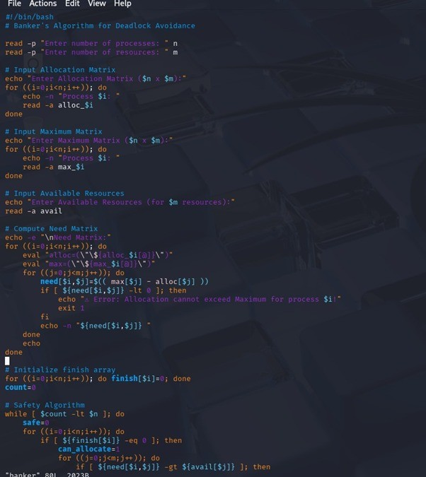

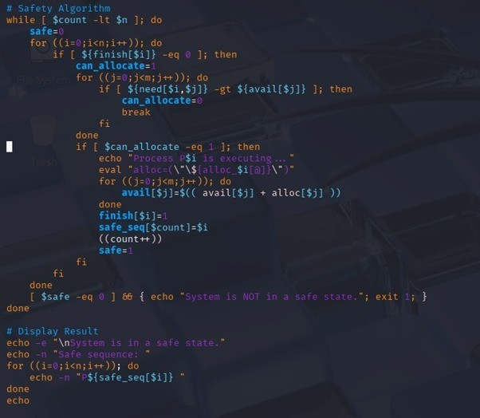

## OUTPUT

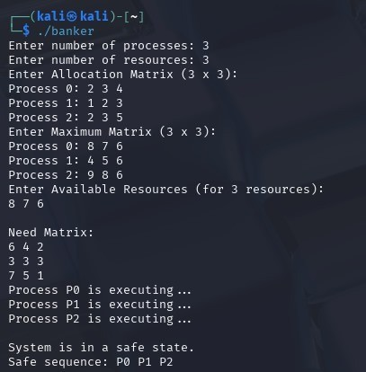

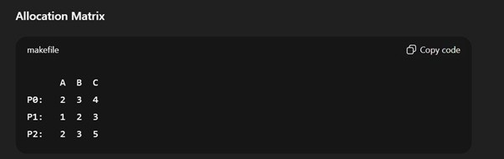

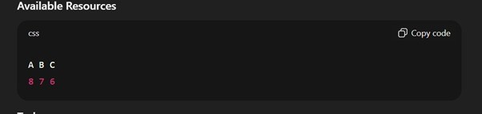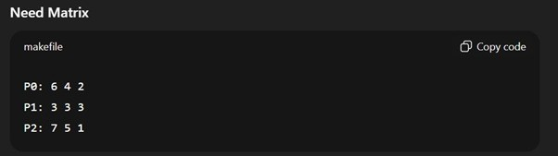

## Experiment No: 12

|  |
| --- |
| **Student Name and Roll Number: Kunal sharma 23csu396** |
| **Semester /Section: 5th / Data Science A** |
| **Link to Code:** |
| **Date: 3/11/25** |
| **Faculty Signature:Dr Asha Sohal** |
| **Marks:** |
| **Objective:**  Write a program for page replacement policy using a) LRU b) FIFO c) Optimal. | |
| **Outcome:**  The students will understand concept of memory management through various page replacement policy using a) LRU b) FIFO | |
| **Problem Statement:**  Write a program to implement page replacement policy using a) LRU b) FIFO c) Optimal. | |
| **Background Study:**  In operating systems that use paging for memory management, page replacement algorithm are needed to decide which page needed to be replaced when new page comes in. Whenever a new page is referred and not present in memory, page fault occurs and Operating System replaces one of the existing pages with newly needed page. Different page replacement algorithms suggest different ways to decide which page to replace. The target for all algorithms is to reduce number of page faults. | |
| **Question Bank:**  1. The main memory accommodates ____________   1. operating system 2. cpu 3. user processes 4. **all of the mentioned**   2. What is the operating system?   1. in the low memory 2. in the high memory 3. **either low or high memory (depending on the location of interrupt vector)**d) none of the mentioned | |

3. In contiguous memory allocation ____________

1. **each process is contained in a single contiguous section of memory**
2. all processes are contained in a single contiguous section of memory
3. the memory space is contiguous
4. none of the mentioned

4. The relocation register helps in ____________

1. providing more address space to processes
2. **a different address space to processes**
3. to protect the address spaces of processes
4. none of the mentioned

5. With relocation and limit registers, each logical address must be _______ the limit register. **a) less than**

1. equal to
2. greater than
3. none of the mentioned

# Student Work Area

## Algorithm/Flowchart/Code/Sample Outputs

Write a program for page replacement policy using a) LRU b) FIFO c) Optimal.

Source code #!/bin/bash

echo "Enter number of pages:" read n echo "Enter page reference string:" read -a pages echo "Enter number of frames:" read f

# ---- FIFO ---fifo() { frames=() pos=0 hit=0 miss=0 echo -e "\nFIFO page replacement:" for ((i=0;i<n;i++)); do page=${pages[i]} found=0

for j in "${frames[@]}"; do

[ "$j" = "$page" ] && found=1 && hit=$((hit+1)) done

if [ $found -eq 0 ]; then miss=$((miss+1)) frames[$pos]=$page pos=$(( (pos+1) % f ))

fi

echo -n "Page $page -> ${frames[*]} " echo "" done echo "FIFO Hits: $hit, Faults: $miss"

}

# ---- LRU ---lru() { frames=() hit=0 miss=0

echo -e "\nLRU page replacement:"

for ((i=0;i<n;i++)); do page=${pages[i]} found=0

for j in "${frames[@]}"; do

[ "$j" = "$page" ] && found=1 && hit=$((hit+1)) done

if [ $found -eq 0 ]; then miss=$((miss+1)) if [ ${#frames[@]} -lt $f ]; then frames+=($page)

else

# Find LRU index min=999 victim=0 for ((x=0; x<f; x++)); do last=-1

for ((k=i-1; k>=0; k--)); do if [ ${frames[x]} = ${pages[k]} ]; then last=$k; break; fi

done if [ $last -lt $min ]; then min=$last; victim=$x; fi done frames[$victim]=$page

fi fi

echo "Page $page -> ${frames[*]}" done

echo "LRU Hits: $hit, Faults: $miss"

}

# ---- OPTIMAL ---optimal() { frames=() hit=0 miss=0

echo -e "\nOptimal page replacement:"

for ((i=0;i<n;i++)); do page=${pages[i]} found=0

for j in "${frames[@]}"; do

[ "$j" = "$page" ] && found=1 && hit=$((hit+1)) done

if [ $found -eq 0 ]; then miss=$((miss+1)) if [ ${#frames[@]} -lt $f ]; then frames+=($page)

else far=-1 victim=0 for ((x=0; x<f; x++)); do next=999 for ((k=i+1; k<n; k++)); do if [ ${frames[x]} = ${pages[k]} ]; then next=$k; break; fi

done if [ $next -gt $far ]; then far=$next; victim=$x; fi done frames[$victim]=$page

fi fi

echo "Page $page -> ${frames[*]}" done

echo "Optimal Hits: $hit, Faults: $miss"

}

